Interview information sheet and consent form for parents and carers

What is the interview about?
We want to understand what is important to children who live in kinship care. This means children who live with relatives or family friends instead of their birth parents.

We want to hear directly from children aged 7–17 about their experiences. This includes how they feel, their relationships, their school life, and what would help them feel more supported.

Who is it with?
This study is carried out by Coram, a children’s charity. The Department for Education funds the study.
A member of the Coram research team will talk with your child. The lead researcher is Hannah Lawrence, Senior Research Manager at Coram.

What will my child be asked to do?
Your child can take part in a one-to-one session or a small group session. The session will last 45 to 90 minutes. The session includes simple, child-friendly activities such as:

- drawing
- mapping relationships
- talking about what matters to them
- using objects or pictures to share their ideas

Sessions can take place in person (for example, at a school, youth centre or community venue) or online, depending on what works best.

Why do we want to talk to your child?
Your child is living in kinship care. Your local authority or a trusted community organisation has identified them as someone who may want to share their views.
Taking part is completely voluntary.

Recording the discussion

We would like to audio record the session. This helps us listen carefully to what your child says and write accurate notes afterwards.
If your child makes a drawing, we will ask if they would like to take it home. If they do, we will take a photo of the drawing and store it securely. If not, we will keep the original drawing.
We will not share the recording outside the Coram team. We will store it securely and delete it when we publish the report.
Before we start, we will ask your child if they are happy to be recorded. If they prefer, we can take notes instead.
How will information be used?
Your child’s discussion with the Coram researcher is confidential. We will not share what they say outside the Coram team.
If we use quotes from the session, we will remove names and any details that could identify your child. No one will be able to recognise them in the research.
We will only share something your child says if we are worried that they or someone else is not safe. If this happens, the researcher will explain to your child what will be shared and who it will be shared with.

What will we do with what your child has told us?
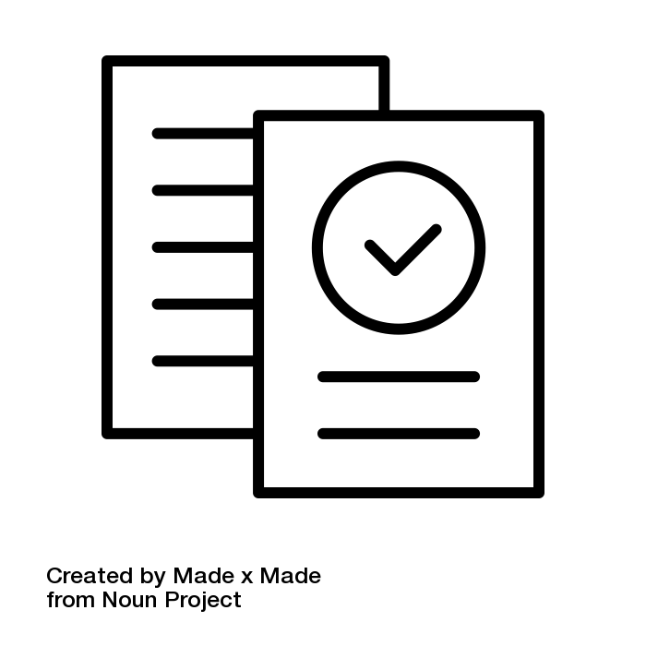
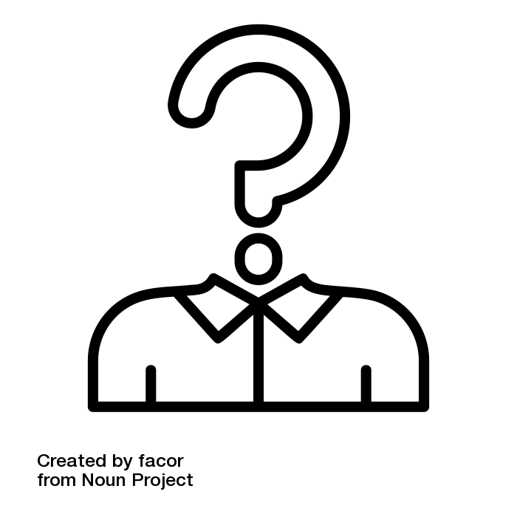
What we learn from talking with your child will help us write a report about the experiences of children in kinship care. The report will be public and shared with the Department for Education.
The research may also appear on the Coram website or in the media.
We can give you or your child a copy of the report if you want to read it.
Even after the session, you or your child can ask us to remove all or part of what was said from the report. Just let us know before 30 August 2026.

Anonymity
Your child will stay anonymous. This means their name and any details that could identify them will not appear in the report.


Could it be upsetting for your child to take part?
We know that talking about family can sometimes be difficult or upsetting.
Your child does not have to answer any question they don’t want to. We can take a break or stop the session completely if they prefer.
We will always be kind and supportive during the session. We can also give you or your child information about other places to get support if needed.

Safeguarding and wellbeing
All researchers are trained to work in a way that is sensitive to children’s experiences and follow Coram’s safeguarding rules.
If a safeguarding concern comes up, we may need to share information with the local authority. We will explain this clearly to your child.

Are you happy for them to take part?
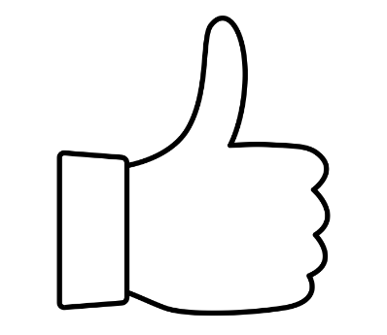
If you are happy for your child to take part, great!
Please get in touch with Mia or Hannah (through email or WhatsApp below) and we can arrange a time to speak.
In the meantime, please fill out the consent form on the next page and send it to mia.johnson@coram.org.uk

How to contact us

We are always happy to answer any questions you have. You can contact us by:

Calling, texting or WhatsApp messaging: 07805 813071
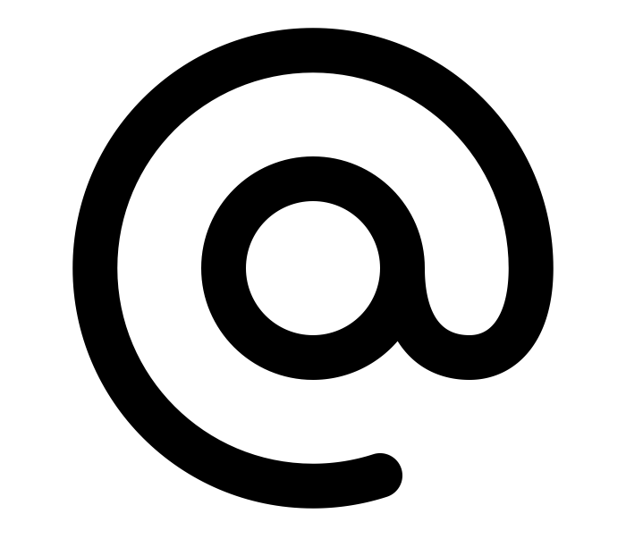
Calling: 020 7520 0365 (Mon to Fri, 9am to 5pm)

Emailing: research@coram.org.uk
Writing to: Coram Impact & Evaluation, 41 Brunswick Square, London WC1N 1AZ


Consent form

Please circle ‘Yes or ‘No’ for each statement:
Remember, you can always say ‘No’
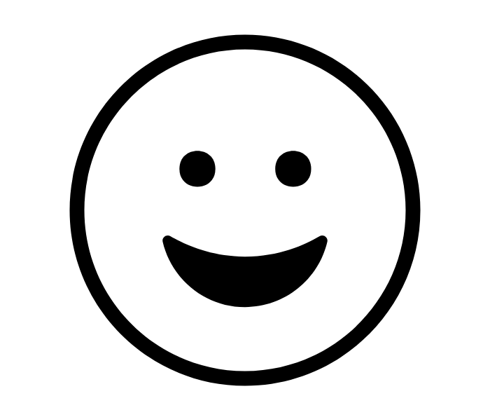 | I have read and understood the information and I am happy for my child to participate in an interview. | Yes | No

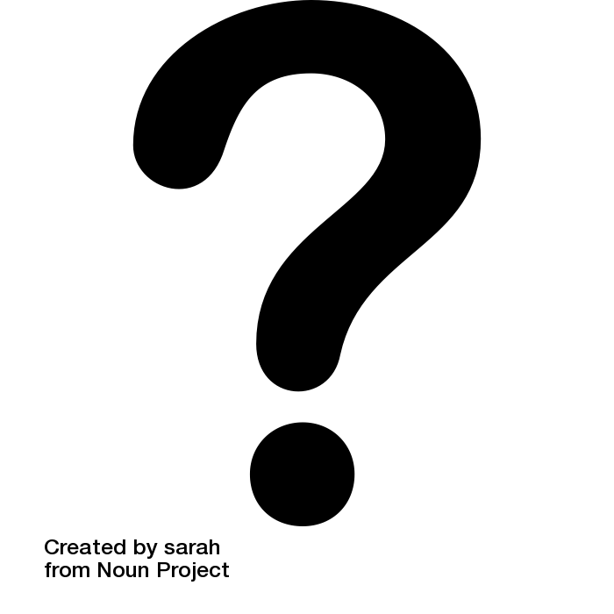 | I have been given the opportunity to ask questions about the information sheet. | Yes | No

 | I understand that what my child says will be confidential (not discussed with anyone outside the Coram research team) unless a Coram researcher has concerns about their or somebody else’s safety. | Yes | No
a
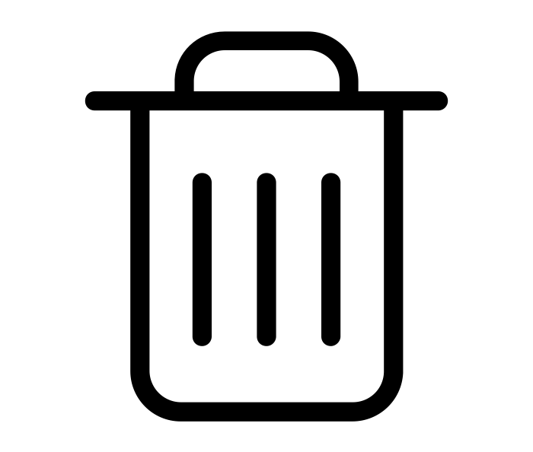 | I understand that I/my child can request to have what they’ve said removed from the research before 30 August 2026 using Coram’s contact details above. | Yes | No

Please write your name:
Please write today’s date:

Thank you!

