Adoption and Special Guardianship Leadership Board

Quarterly Data Collection

Guide to the ASGLB data collection 2019-20 (Q1)

July 2019

Contact details
For general enquiries or feedback about the Adoption and Special Guardianship Leadership Board quarterly data collection, please contact ASGLB@coram.org.uk

Contents
Introduction 3
Summary of main changes for 2019-2020 3
Regional adoption agencies 3
1. Overview of the ASGLB data collection 5
1.1 Purpose of the data collection 5
1.2 Completing the ASGLB data return 5
1.3 Submitting data 8
1.4 Validation checks 9
1.5 Frequently asked questions 9
2. Child level guidance 11
2.1 Overview 11
2.2 Section A: Child characteristics 11
2.3 Section B: Key dates and outcomes of the adoption process 14
2.4 Section C: Reversals and disruptions 17
3. Adopter level guidance 18
3.1 Overview 18
3.2 Section A: Adopter characteristics 18
3.3 Section B: Key dates and outcomes of the adoption process 21
3.4 Section C: Disruptions 23
4. Special Guardianship Orders (SGOs) 24
5. Other data 25
5.1 Adoption support 25
5.2 Complaints and allegations 26
5.3 Inter-country adoptions 26
Annex A – LA Codes 28
Annex B – RAA Codes 29
Annex C – VAA Codes……………………………………………………………………………………………………………………29

Introduction
This document gives guidance on the completion and submission of the Adoption and Special Guardianship Leadership Board (ASGLB) quarterly data collection for 2019-20.
The ASGLB return should be completed by every local authority, voluntary adoption agency, and regional adoption agency in England on a quarterly basis. Voluntary adoption agencies elsewhere in the UK also complete the return on a voluntary basis. Local authorities are asked to provide child level data for every child looked after at any stage of the adoption process, and adopter level data for every (prospective) adopter at any stage of the adoption process (unless adopter recruitment is being carried out on their behalf by a regional adoption agency). Regional adoption agencies and voluntary adoption agencies are asked to provide adopter level data only.
In addition, local authorities are asked to complete the section on special guardianship orders each quarter. Both local authorities and voluntary adoption agencies are asked to complete data on adoption support, intercountry adoption, and complaints on an annual basis for the purposes of informing Ofsted inspections.
The data that is provided may be shared in an anonymised form with other parties for research purposes. Agencies should ensure that their privacy notices reflect this.
This document may be freely distributed and is available on Coram’s website.

Summary of main changes for 2019-20
In April 2019 the Department for Education awarded Coram-i the contract for delivering the provision of a secretariat service to the Adoption and Special Guardianship Leadership Board, the Residential Care Leadership Board and the National Stability Forum and for the quarterly collection, analysis and publication of adoption data. From 1st July 2019 Coram will manage the ASGLB data collection and all ASGLB data returns should be submitted to Coram-i at- ASGLB@coram.org.uk
All adopters should now be going through the two stage process and so data fields B6 (Date application submitted) and B7 (Date application approved) have been removed from the adopter level sheet. Please note that the data fields B6 to B9 have been amended to reflect this change. If there are any adopters who went through the old approval process, please complete B2 as their application submitted date and B5 as their application approved date.

Regional adoption agencies
Regional adoption agencies are generally expected to manage all adopter recruitment, assessment and approval on behalf of the local authorities in their region. We expect this will involve a transfer of adopters approved/in the process of being approved from member local authorities to the regional adoption agency. Meanwhile, local authorities will retain responsibility for the children in their care.
On this basis, the approach to managing the ASGLB data collection where regional adoption agencies are established is that:
- Local authorities will continue to provide child level data for the children in their care in the adoption process; but not data for adopters, since this is the responsibility of the regional adoption agency. They will also continue to provide data on SGOs.
- Regional adoption agencies will be asked for adopter level data only. They will be treated as distinct entities, with new URNs assigned. Since local authorities retain responsibility for reporting on the children, the regional adoption agency will not be responsible for providing child level data.
This approach should be implemented from the quarter in which the regional adoption agency ‘goes live’. For example, for a regional agency going ‘live’ on 1st April 2019, the local authorities in that region will continue to provide child level data from Q1 2019-20 onwards, but cease providing data on adopters. Instead, the regional adoption agency will provide a single return under a new URN code covering all adopters active at any point in the process during the period 1st April – 30th June 2019. This will include any adopters that had been transferred from the member local authorities to the regional adoption agency, as well as adopters new to the process that quarter.

1. Overview of the ASGLB data collection

1.1 Purpose of the data collection
The primary aim of the ASGLB data collection is to collect information about children in the adoption process and (prospective) adopters to enable decision-making at national, regional and local level to be evidence-based and informed by strong intelligence, and for agencies and regional boards to have the information they need to improve performance.
The collection is governed by the following principles:
- Sector ownership. The ASGLB data collection is governed through a data reference group constituted by a range of data users and providers and is managed by the Coram-i on behalf of the sector.
- Relevance. All items collected should be meaningful in the context of helping inform decision-making at all levels of the system in order to improve outcomes for children. Data items that are not meaningful in this context should not be collected.
- Clarity. The purpose and processes involved in the data collection should be clear and understood by all parties involved in the collection, and the collection should not involve undue burden on agencies.
- Accessibility. Data should be shared with those that need it in a timely way, and presented in a format that is useful and accessible.

1.2 Completing the ASGLB data return
Data is commissioned on the first working day of each quarter. Agencies are then normally asked to complete and submit quarterly data by the last working day of the month the data is commissioned. The exception to this is in Q4 of each year, where agencies are asked to provide data covering the full financial year (1 April to 31 March). In these situations, the deadline will be extended to allow approximately 10 weeks for data to be returned. This allows extra time to complete the full year’s return and for local authorities to cross-reference their data with the SSDA903 return that is completed over the same period.

Entering data
Before you begin, fill in the details in the summary sheet. Please select your agency’s name from the drop-down list. A list of agencies and their URNs is provided in the ‘URN data’ tab. Please also enter your name and email address in the fields provided.
If you are typing data directly into the form you will notice that there are validation rules in most cells, which only allow data to be entered in a particular format, as specified in these guidance notes. If you try to enter data in other formats, an error message will appear and the data will need to be corrected.
If you are copying and pasting into the form you will notice that error messages and conditional formatting (invalid information turns the cell red) will appear where applicable once data has been pasted into cells. The standard validation rules will not work on data that is copied and pasted; however, any data not entered in the appropriate format will turn the relevant cells red, and will be flagged during validation.
Please do not leave blank rows between rows of data; the validation cannot run in this case.
If you are pasting data into the form, please paste data as values. If you do not, the conditional formatting in the cells will not work.

Checking data
All forms must have validation run before submission. Any forms submitted without this will be returned for validation to be run.
Run validation by going to the ASGLB Data Validation menu, and clicking “Validate”:
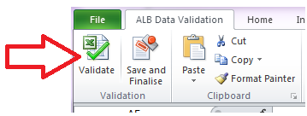
Depending on the number of records, this may take up to 10 minutes; for smaller agencies, it will be much quicker.
A pop-up will tell you which tabs still have errors; or if you have no errors, the pop-up will confirm this.
If the ASGLB Data Validation menu is not visible, this is likely because macros have been disabled by your IT system. If prompted, do not disable macros when downloading the form.
There are two error report tabs, highlighted in blue; these will be populated with data on errors in the form. If the tab is blank, there are no errors. There is no error report tab for Other data:
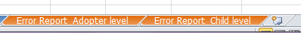
The error reports are split into:
- Missing: data which is required but has not been entered e.g. Stage 2 start date blank when Stage 2 end date is entered.
- Not valid: data which has been entered in an incorrect format e.g. a date entered as 12-Dec-2015, instead of 12/12/2015, more than 5 children under the same family ID, or White instead of WBRI.
- Other errors: mistakes in the data entered e.g. a start date after an end date instead of before, or data about brothers and sisters for a child you’ve said doesn’t have any.
If all three error types are present in one row of data, there will be one row in the error report for each error type. Use the blue link to navigate to the row, and the colour-coding and error messages to correct mistakes, or enter missing data:

We advise that missing data be entered first, and then validation re-run. This will show any additional errors in the newly entered data.
The validation can be run as many times as needed to complete and resolve all errors. Please note that the error report is a static document – error messages do not disappear as the error is resolved. For an up to date list of remaining errors, please press “Validate” again.
Once all errors have been resolved, click “Save and finalise”. For files not being sent via secure email, please ensure a password is added to the file and the file saved before sending off.
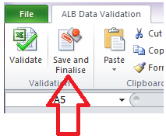
The file can be saved at any point using the normal “Save” function.
For QA purposes, the form tracks the running of validation and finalising, including the date this was done. This includes collecting and storing the name of the person who completed the form. This information is used to confirm that validation has been run before the form was submitted, and to ensure the ASGLB can make contact with the correct person to clarify any errors observed after completion.

1.3 Submitting data
Please submit your completed return securely through Egress Switch to ASGLB@coram.org.uk
Returns do not need to be password protected and must not be sent via unsecured email. We will not be continuing to monitor the S2S system. Please do not submit returns via this route.
To create and use a free Egress Switch account:
- Go to https://www.egress.com/en-US
- Go to register
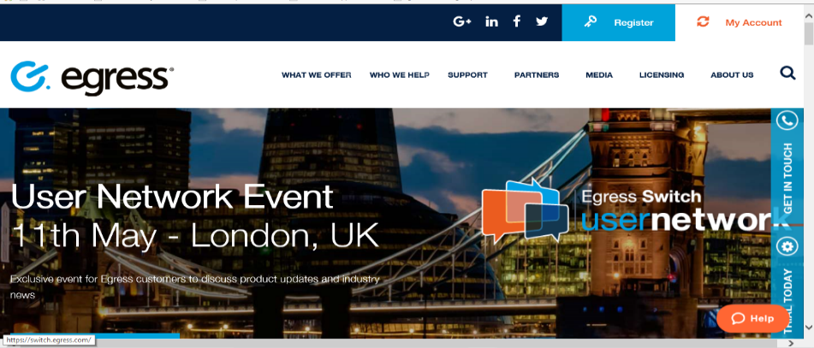

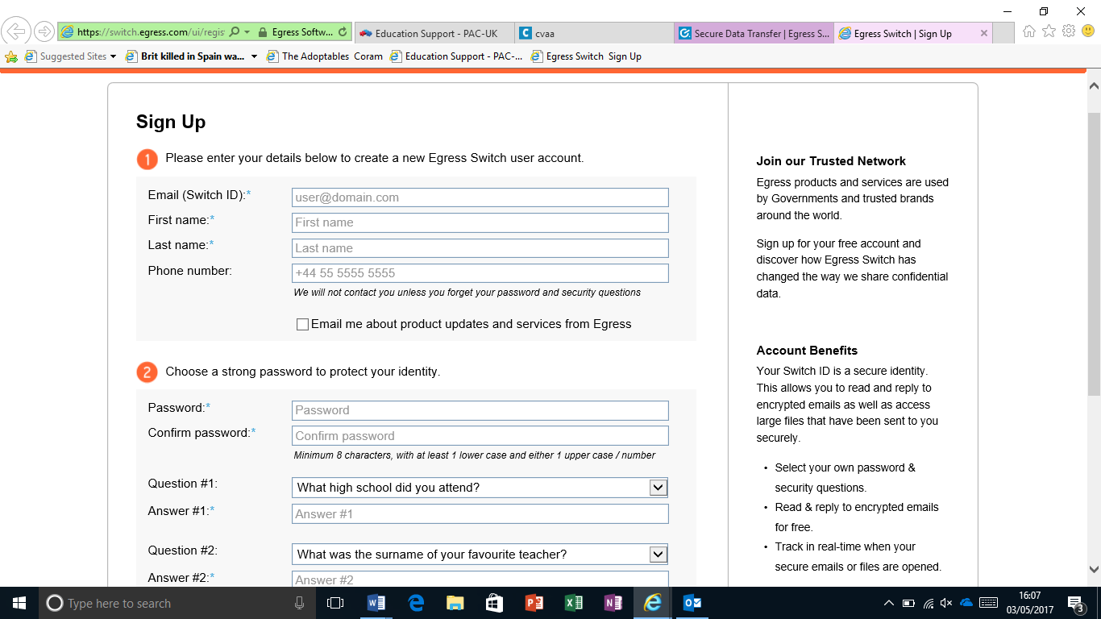
- Fill in your details here. Make sure that you use the email address that you will be using to submit the data return.
Do not forget to opt out here if you do not wish to receive promotional emails from Egress.

- Once you have created a switch account, you can send secure emails by logging into the online portal at https://switch.egress.com/ui/signin.aspx?returnUrl=https%3a%2f%2fswitch.egress.com%2fui%2fadmin%2fdefault.aspx

- To compose an email, select ‘New Secure Email’
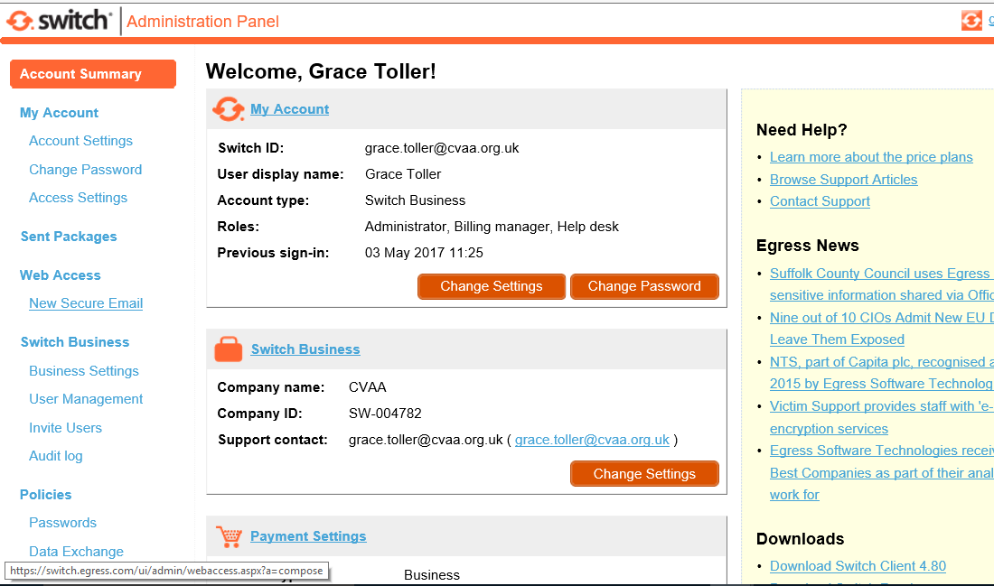

- Then simply compose an email and send toASLGB@coram.org.uk

1.4 Validation checks
As described above, the validation checks built into the data template are designed to check for missing data, incorrect formatting, and for unlikely or impossible combinations of information.
These checks are not intended to add undue burden on the data collection; they are merely designed to identify and query data which are likely to be in error. In some cases, the validation checks will flag correctly entered data as erroneous. This will usually be because of unusual circumstances in that particular case. If, after checking, the data is found to be accurate, please ignore the relevant error message.

1.5 Frequently asked questions
Why can’t I add columns or rows to the workbook?
The workbook structure and individual tabs have been protected to prevent the addition of new columns or rows to tabs in the workbook. This is because making these changes would prevent the validation checks from functioning properly.
Can I copy and paste data into the template?
Yes. Please ensure you paste any data in as values – this will ensure that the conditional formatting built into the template works properly to highlight invalid information in red. If you do not paste data as values this will overwrite the conditional formatting.
Why am I getting an error message for an adopter that has gone straight to stage 2?
The validation checks are designed to highlight impossible or unlikely combinations of information or dates. Where adopters have dates for stage 2 but not stage 1, this will be flagged as an error message, unless the adopters have been identified as repeating the process and therefore able to go straight to stage 2.
What do I do if I am getting an error message but the data is correct?
In some cases, the validation checks will highlight unlikely combinations of information or dates as an error. If you are confident that the information you have entered is correct, you should ignore any wrong error messages, and write a note to explain in the comments section.
How do I fill in A2b (family identifier)?
Enter the family identifier for the adoptive family that child is matched/placed with. If you do not have a family identifier (e.g. because the child has not been matched with a family, or is being placed interagency) you may leave this blank.

2. Child level guidance

2.1 Overview
This section relates to the “Child level” tab of the data collection template.
All local authorities are required to complete this section of the return; regional adoption agencies and voluntary adoption agencies are not.
Record one row per child. Children adopted as part of a sibling group should have one row each.
Information should be recorded for all children at any stage of the adoption process, i.e. from the decision that child should be placed for adoption to final adoption order, even if there was no change in status during the quarter.
If an ADM (Agency Decision Maker) decision has been reversed during the current quarter, include them in the quarter for which the reversal was made (and provide a reversal date and reason) but exclude them from the cohort from the following quarter onwards.
Definitions are as recorded in the guidance for the SSDA903 return on Looked After Children unless otherwise specified.
Note that analysis on adoption breakdowns are not included as they are collected in the 903 dataset and analysed through qualitative research.

2.2 Section A: Child characteristics
A2a Child identifier
Record your local child identifier for each child. This must be a unique ID, no longer than 10 characters, and retained from year to year. Do not use non-numeric or non-alphabetic characters.

A2b Family identifier
Record your local adoptive family identifier for the adoptive family the child is matched or placed with. This is a unique identifier that flags each family unit, and should match up with numbers used in ‘A3 family identifier’ in the adopter level tab. If you do not have a family identifier (e.g. because the child has not been matched with a family, or is being placed interagency) you may leave this blank.

A3 Gender
Use the following code list:
0 | Not known (gender not recorded or unknown for unborn children)
1 | Male
2 | Female
9 | Neither (indeterminate i.e. unable to be classed as either male or female)

A4 Date of birth
Record date of birth using the following format: DD/MM/YYYY

A5 Ethnic origin
Use the following code list:
WBRI | White British | APKN | Pakistani
WIRI | White Irish | ABAN | Bangladeshi
WOTH | Any other White background | AOTH | Any other Asian background
WIRT | Traveller of Irish Heritage | BCRB | Caribbean
WROM | Gypsy/Roma | BAFR | African
MWBC | White and Black Caribbean | BOTH | Any other Black background
MWBA | White and Black African | CHNE | Chinese
MWAS | White and Asian | OOTH | Any other ethnic group
MOTH | Any other Mixed background | REFU | Refused
AIND | Indian | NOBT | Information not yet obtained

A6 Disability
The Disability Discrimination Act 2005 defines a disabled person as a person with a “physical or mental impairment which has a substantial and long-term adverse effect on his ability to carry out normal day-to-day activities.” The condition must have lasted or be likely to last at least 12 months in order to be counted as a disability. Record 1 (= Yes) if the child is classified as being disabled with any of the definitions listed below from the Children in Need (CIN census). Record 0 (= No) if the child has no disability. (Also see pages 27-28 of the 2018/19 CIN census Guidance Notes).

Mobility | Getting about the house and beyond
Hand function | Holding and touching
Personal care | Eating, washing, going to the toilet, dressing, etc.
Incontinence | Controlling the passage of urine or faeces
Communication | Speaking and/or understanding others
Learning /Hearing /Vision | Having special educational needs, etc.
Behaviour | A condition entailing behavioural difficulties, includes Attention Deficit Hyperactivity Disorder (ADHD)
Consciousness | Seizures
Autism or Asperger Syndrome | Diagnosed by a qualified medical practitioner as having classical autism or Asperger syndrome. Do not include children who have merely been identified as having an Autistic Spectrum Disorder (ASD), e.g., by their school. This can be associated with the behaviour and learning categories above.
Other DDA | One or more of the child’s disabilities under the Disability Discrimination Act 2005 does not fall into any of the above categories.
A7a Sibling Group
Using locally-held information, record if the child is part of a sibling group of two or more that is being considered for adoption as a group. Record 1 (= Yes) if the child is being considered for adoption as part of a sibling group of two or more; or 0 (= No) if that is not the case.

A7b Number of children placed (or planned to be placed) together as sibling group
If the answer to A7a is yes, record the number of children being considered / placed for adoption as a group, including the child in question.

A7c Number of siblings placed (or planned to be placed) apart from child
Record the number of sibling being considered / placed for adoption apart from the child.

A7d Were these children originally assessed to be placed apart
If there are siblings being placed apart from the child, record 1=Yes or 0=No if this was the original plan.

A8a Placement provider code
Record who approved the adoptive family the child has been placed with using the following code list:
PR1 | Own provision (by the local authority)
PR2 | Other local authority provision (includes regional adoption agencies)
PR5 | Voluntary adoption agency

A8b Placement provider URN
Record the Ofsted unique reference number (URN) of the agency providing the placement.

The URN is in the format SC999999, 999999 for Secure Training Centres or 9999999 for newly registered providers. A full table of URN codes is provided in the ‘URN data’ tab.

Ofsted will provide local authorities with complete lists of URNs for inspected providers which are open at any point during the collection year. Currently this is supplied on a monthly basis to named individuals, of whom there can be up to five per authority. Local authorities nominate these individuals by contacting enquiries@ofsted.gov.uk and recipients will require a secure email address [.gsi; .gsx; .gcsx; or .cjsm.net].

2.3 Section B: Key dates and outcomes of the adoption process
Record all the relevant dates for all children at any stage of the adoption process, i.e. from decision that child should be placed for adoption to final adoption order, even if there was no change in status during the quarter. Each child should have a minimum of 2 dates recorded against them, e.g. at least B1 and B2b.

B1 Date child entered care
Record the date the child entered the current period of continuous care using the following format: DD/MM/YYYY

B2a Date of decision that the child should be placed in a fostering for adoption (FFA) or concurrent planning placement
Record the date of decision that the child should be placed with a selected family under a fostering for adoption (FFA) or concurrent planning arrangement using the following format: DD/MM/YYYY

This is the date on which the local authority formally decides that a child should be placed in a fostering for adoption (FFA) or concurrent planning placement. This decision must not be confused with the decision where the local authority decides that a child should be placed for adoption.

Where a child has had concurrency/FFA approved but have not yet had the decision for adoption they should still be included in the return.

B2b Date of decision that the child should be placed for adoption
Record the date of the decision that the child should be placed for adoption using the following format: DD/MM/YYYY

This is the date on which the local authority formally decides that a child should be placed for adoption, i.e. the date the agency decision maker takes the decision to endorse the proposed adoption plan for the child.

B3 Date of Placement Order or Freeing Order
Record the date a Placement order or Freeing order was granted using the following format: DD/MM/YYYY. This can be ascertained from the date when a child's legal status has changed to E1 (Placement order granted) or D1 (Freeing order granted).

B4 Date child was matched to prospective adopters
Record the date the ADM approved a match for the child with the selected prospective adopters using the following format: DD/MM/YYYY

This is the date on which the local authority formally decides that the child should be placed for adoption with the particular prospective adopters.

B5a Date the child was placed for fostering in FFA or concurrent planning placement
Record the date the child is placed for fostering in FFA or a concurrent planning placement using the following format: DD/MM/YYYY

This is the date that child goes to live with the prospective dually approved foster carers who are likely to adopt them. It does not mean that the child has been adopted.

B5b Date the child was placed for adoption with prospective adopters
Record the date the child is placed for adoption with particular prospective adopters using the following format: DD/MM/YYYY. Or, if the child was placed with their foster carers or were in a FFA/concurrent planning placement, record the date this placement changed from a foster placement to an adoption placement – this should be the same as B4.
This is the date that child goes to live with the prospective adopters who will adopt them. It does not mean that the child has been adopted.

B6 Date child was placed with the foster carer
If the child was adopted by their foster carer, enter the date they were placed with the foster carer using the following format: DD/MM/YYYY

B7 Date of Adoption Order
Record the date an Adoption order was granted using the following format: DD/MM/YYYY. This can be ascertained from the date when a child's episode of care ceased due to E11 (Adopted - application for an adoption order unopposed) or E12 (Adopted – consent dispensed with by court)

B8 Placement at adoption
Record one of the following placement types:

A3 | Placed for adoption with parental/guardian consent with current foster carer (under section 19 of the Adoption and Children Act 2002) or with a Freeing order where parental/guardian consent has been given under section 18(1)(a) of the Adoption Act 1976
A4 | Placed for adoption with parental/guardian consent not with current foster carer (under section 19 of the Adoption and Children Act 2002) or with a Freeing order where parental/guardian consent has been given under section 18(1)(a) of the Adoption Act 1976
A5 | Placed for adoption with placement order with current foster carer (under section 21 of the Adoption and Children Act 2002) or with a Freeing order where parental/guardian consent was dispensed with under section 18(1)(b) the Adoption Act 1976
A6 | Placed for adoption with placement order not with current foster carer (under section 21 of the Adoption and Children Act 2002) or with a Freeing order where parental/guardian consent

B9 FFA/concurrent planning adoptions with same carer
Flag if the FFA adoption was completed with the same carer recording 1=Yes or 0=No.

2.4 Section C: Reversals and disruptions
C1a Date of decision that the child should no longer be placed for adoption
Record the date that the local authority formally decides that a child should no longer be placed for adoption using the following format: DD/MM/YYYY

C1b Reason why the child should no longer be placed for adoption
Record one of the following reason codes:
RD1 | The child’s needs changed subsequent to the decision
RD2 | The court did not make a placement order
RD3 | Prospective adopters cannot be found
RD4 | Any other reason

C2 Date of disruption
Record date that adoption placement was disrupted prior to adoption order. If the decision to place the child for adoption has been reversed, record this information in C1a and C1b instead of C2.

C3 Family-finding
Record one of the following to indicate whether your authority is actively seeking adoptive families for this child:
1 | Currently family finding for this child
2 | Not family-finding, order currently being appealed / revoked
3 | Not family-finding, family found, but not yet formally matched at panel
4 | Not family-finding, other reason

3. Adopter level guidance

3.1 Overview
This section relates to the “Adopter level” tab of the data collection template.
Local authorities are not required to fill in this section where these functions are being carried out by a regional adoption agency on their behalf.
Record one row per adopter. Where the adoptive family is a couple, two rows should be provided. Each adopter will have their own record for the adopter characteristics in section A but the dates for each stage of the process in section B will be identical. If you currently only collect data at adoptive family level, this will be accepted, but note whether this is a one or two-person adopter family in the comments column.
Information should be recorded for all prospective adopters at any stage of the adoption process, i.e. from application (or start of Stage 1) to final adoption order, even if there was no change in status during the quarter. Include all prospective adopters who have made an application to your agency, even if they are being matched to children from another local authority. Adopters should be removed from the cohort in the quarter after the adoption order. So, if an adopter received an adoption order in quarter 1 2019-20, include them in the quarter 1 return but remove them from the quarter 2 2019-20 return. If adopters are no longer going through the recruitment process for any other reason, enter the date of leaving the process (C2a) and reason for leaving the adoption process (C2b) and exclude them from the cohort in the following quarters return.
Note that we only require information about prospective adopters who have made an application; you do not need to include people who have only made enquiries.
If an adopter’s recruitment process is put on hold due to circumstances beyond the agency’s control, remove them from the cohort until the process restarts. Use the comments column to let us know that this has happened.
If an adopter applies to adopt again having already been through the process, use a different adopter and family identifier and let us know in the comments column.

3.2 Section A: Adopter characteristics
A2 Individual adopter identifier
Record your local adopter identifier for each (prospective) adopter. Each member of an adoptive family needs their own unique adopter identifier.

A3 Family identifier
Record your local adoptive family identifier for each (prospective) adoptive family. This is a unique identifier that flags each family unit and each time they progress through an assessment. For example, a couple should share one family identifier in A3 but two individual adopter identifiers in A2 (each with their own line with A3 replicated for both). These will have their own records for items in section A but dates for section B will be identical. If you do not currently collect family identifiers, please make one up for the purposes of this return – the family identifier should be consistent across multiple returns where the data represents a single journey. If a family starts a subsequent assessment, a new family identifier should be allocated.

A4 Gender - Use the following code list:
0 | Not known | 2 | Female
1 | Male | 9 | Neither

A5 Date of birth
Record date of birth using the following format: DD/MM/YYYY

A6 Religion
Use the following code list:
Bu | Buddhist | Je | Jewish | Ot | Other
Ch | Christian | Mu | Muslim | Re | Refused
Hi | Hindu | No | None | Na | No information available

A7 Sexual Orientation
Use the following code list:
He | Heterosexual | Ga | Gay | Ot | Other
Le | Lesbian | Bi | Bisexual | Re | Refused
 |  |  |  | Na | No information available
A8 Ethnic Origin
Use the following code list:

WBRI | White British | APKN | Pakistani
WIRI | White Irish | ABAN | Bangladeshi
WOTH | Any other White background | AOTH | Any other Asian background
WIRT | Traveller of Irish Heritage | BCRB | Caribbean
WROM | Gypsy/Roma | BAFR | African
MWBC | White and Black Caribbean | BOTH | Any other Black background
MWBA | White and Black African | CHNE | Chinese
MWAS | White and Asian | OOTH | Any other ethnic group
MOTH | Any other Mixed background | REFU | Refused
AIND | Indian | NOBT | Information not yet obtained

A9 Disability
The Disability Discrimination Act 2005 defines a disabled person as a person with a “physical or mental impairment which has a substantial and long-term adverse effect on his ability to carry out normal day-to-day activities.” The condition must have lasted or be likely to last at least 12 months in order to be counted as a disability. Record 1 (= Yes) if the adopter is classified as being disabled under this definition. Record 0 (= No) if the adopter has no disability.

A10 Relationship status
Use the following code list:
SIN | Single | OTH | Other
MAR | Married | REFU | Refused
CIV | Civil partnership | NOBT | Information not yet obtained
CLM | Male/female partnership
SSP | Same sex partnership

A11 Was the (prospective) adopter the child(ren)'s foster carer originally?
Flag if the (prospective) adopter was originally looking after the child(ren) as part of a foster care arrangement that has since switched to an adoptive placement using 1=Yes and 0=No.

A12 Is the (prospective) adopter fostering for adoption?
Flag if the (prospective) adopter is fostering for adoption (FFA) or has a concurrent planning placement using 1=Yes and 0=No.
If their placements are converted to adoption keep the FFA flag as ‘1’. If the plan changes and the adopter is matched to a new child and they are no longer FFA change this flag to ‘0’.

A13a Was the child in care of your own LA? [LAs only]
Flag whether the child(ren) that have been placed with the adopter was in your local authority’s care (=1) or that of another local authority (=0).

A13b URN of child's LA
Record the Ofsted unique reference number (URN) of the local authority in which the child is in care.

The URN is in the format SC999999, 999999 for Secure Training Centres or 9999999 for newly registered providers. A full table of URN codes is provided in the ‘URN data’ tab.

Ofsted will provide local authorities with complete lists of URNs for inspected providers which are open at any point during the collection year. Currently this is supplied on a monthly basis to named individuals, of whom there can be up to five per authority. Local authorities nominate these individuals by contacting enquiries@ofsted.gov.uk and recipients will require a secure email address [.gsi; .gsx; .gcsx; or .cjsm.net].

3.3 Section B: Key dates and outcomes of the adoption process
B1 Date enquiry received
Record the date prospective adopter made initial enquiry (if available) using the following format: DD/MM/YYYY

This is the first contact made by the prospective adopter about becoming an adopter to the adoption agency by the specific adopter.

Note that we only require information about prospective adopters who have made an application; you do not need to include people who have only made enquiries.

All adopters should now be going through the two stage process. If there are any adopters who went through the old approval process, please complete B2 as their application submitted date and B5 as their application approved date.
B2 Date Stage 1 started
Record the date the agency notifies the potential adopter that it has accepted their registration of interest using the following format: DD/MM/YYYY. If the potential adopters are fast-tracked do not record anything under this field

B3 Date Stage 1 ended
Record the date the agency notifies the prospective adopter of their decision that they may be suitable to adopt and can progress to Stage 2 using the following format: DD/MM/YYYY. If the potential adopters are fast-tracked do not record anything under this field

B4 Date Stage 2 started
Record the date the agency receives written notification from the prospective adopter that they wish to proceed into assessment using the following format: DD/MM/YYYY. If the potential adopters are fast-tracked this may be the date their registration of interest has been accepted

B5 Date Stage 2 ended
Record the date the agency notifies the prospective adopter of the Agency Decision-Maker (ADM) decision using the following format: DD/MM/YYYY

B6 Date adopter matched with child(ren)
Record the date the prospective adopters were matched with child(ren) using the following format: DD/MM/YYYY

This is the date on which the local authority ADM formally decides that the child should be placed for adoption with the particular prospective adopters..

B7 Date child/children placed with adopter(s)
Record the date the child is placed for adoption with particular prospective adopters using the following format: DD/MM/YYYY. Or, if the child was placed with their foster carers or were in a FFA/concurrent planning placement, record the date this placement changed from a foster placement to an adoption placement, which should be the same as B6.

B8 No. of children placed
This is the total number of children placed with the approved adopter’s adoptive family. i.e. if a couple adopted two children, each adopter should have two children recorded in this cell.

B9 Date of Adoption Order
Record the date an Adoption order was granted using the following format: DD/MM/YYYY

3.4 Section C: Disruptions
C1 Is the adopter repeating the process?
Flag if the adopter is going through the process again following an earlier adoption using 1=Yes and 0=No.

C2a Date of leaving adoption process
Record the date that the adopter left the process in the following format DD/MM/YYYY. This may include both prospective adopters who left during the recruitment process, and adopters who withdraw from the adoption process at any point after approval.

C2b Reason for leaving adoption process
Record the reason for leaving the process using the following code list:
1 | Adopter withdrew from process
2 | Process put on hold
3 | Application refused

C3 Date of disruption of adoption placement
Record date that the adoption placement was disrupted prior to adoption order using the following format: DD/MM/YYYY.

C4 Date process restarted
If process was put on hold, please provide the date that the process restarted using the following format: DD/MM/YYYY.

4. Special Guardianship Orders (SGOs)
This section of the return is required from local authorities on a quarterly basis.
The information is required at aggregate level, not child level as in the adoption return.
Provide the total number in the quarter of SGO applications made and the number of SGOs that have been granted during the quarter, broken down by whether they are from care or not.
Where multiple applications have been made for the same child, e.g. from different family members, please only include the child once in the count.
Provide breakdowns based on:
- Gender
- Age
- Ethnicity (where “white” is WBRI defined as WBRI, WIRI, WOTH, WIRT and WROM)
- Who the Special Guardian was: “grandparent”, “other family”, “friend / existing relationship”, “former foster carer”, “other carer” (if grandparent, other family or friend were also the former foster carer, please record as either “grandparent”, “other family” or “friend”)
- Sibling group (please record the number of children that belong to a sibling group that are going through the process together as a group rather than the number of sibling groups)
- The number of SGOs granted with a supervision order
- The number of SGOs applied for / granted for children who had previously had an ADM adoption decision
More information about special guardianship, including regulations and statutory guidance, can be found at: https://www.gov.uk/government/publications/special-guardianship-guidance
The statutory guidance clearly sets out the responsibilities of local authorities in relation to special guardianship applications.

5. Other data

5.1 Adoption support
Note: this section is only requested on an annual basis at the end of each financial year.
This section of the return was formerly collected by Ofsted in section D of the adoption dataset.
The information is required at aggregate level, not child level as in the adoption return, and will be collected on an annual basis. This return therefore covers the 12-month period between 1 April 2019 and 31 March 2020.

Requests for adoption support and assessments (LAs only)
Only local authorities are required to submit data about numbers of requests for adoption support. If the RAA is the provider of the adoption support services then this should be completed by the RAA. You do not need to break the information down by individual LA, just provide the totals for the RAA.
Provide the number of requests for post-adoption support that were received during the 12-month period. All formal requests received during the year should be counted, irrespective of when the final adoption order may have been granted. Informal assistance or enquiries should not be counted.
Of these requests, provide further breakdowns based on the outcome of the assessment or whether the assessment was still ongoing:
- How many assessments resulted in the provision of support
- How many assessments did not result in the provision of support
- How many assessments were still being carried out at 31 March 2020

Pre-adoption support, post-adoption support and support to adult adoptees (LAs and VAAs)
These three sections all follow the same format and methodology: the questions request numbers of support packages provided during the year, with further breakdowns of the funding source and the provider type for the support. The distinction between each of the three sections is the recipient of the support:
- Pre-adoption support. This is support provided to families undertaking the adoption process. The support was required and provided prior to the granting of the final adoption order.
- Post-adoption support. This is support provided to families who have adopted. The support was required and provided during the year, irrespective of when the final adoption order was granted.
- Support to adult adoptees. This is support provided to adults who were adopted as children.
Both local authorities and VAAs are required to submit data about adoption support packages provided.
Local authorities should provide data about all adoption support packages provided during the 12-month period. This will therefore include packages that were directly provided or commissioned through other agencies, as identified in each column. For all adoption support packages, provide further breakdown of the funding source for the support.
VAAs should provide data about all adoption support packages provided during the 12-month period. The additional columns relating to adoption support packages commissioned through other agencies will not apply to VAAs. Of the adoption support packages provided by VAAs, provide further breakdown of the funding source for the support.

Contact orders
Please record the number of contact orders applied for and granted under section 51A of the Children and Families Act 2014 by whether the order allowed or prohibited contact.

5.2 Complaints and allegations
This new section of the return was formerly collected by Ofsted in section E of the adoption dataset.
The information is required at aggregate level, not child level as in the adoption return, and will be collected on an annual basis. This return therefore covers the 12-month period between 1 April 2019 and 31 March 2020.
Provide the total number of:
- Complaints received
- Allegations of misconduct against staff or volunteers (where a formal investigation is undertaken, into conduct regarding either employment or safeguarding concerns)
- Allegations relating to child protection against adopters or prospective adopters
- Referrals to the Disclosure and Barring Service (DBS)

5.3 Inter-country adoptions
This new section of the return was formerly collected by Ofsted in section G of the adoption dataset.
The information is required at aggregate level, not child level as in the adoption return, and will be collected on an annual basis.

Inter-country adoption functions
Please state whether your agency offers any services related to inter-country adoption. Record “Yes” or “No”. If your agency has no involvement in inter-country adoption, populate the functions as “No” and the rest of this section will not be required to be completed.
If your agency does offer inter-country adoption services, provide data about:
- Children and young people subject to inter-country adoptions
- Sibling inter-country placements
- Children’s ages when they entered the UK
- Inter-country adoptive families
Note that the time period or date is specified for each question and therefore varies throughout the section.
Some questions require data about the status of adoptions ‘as at 31 March 2020’. The children and approved inter-country adoptive families should be counted according to the status of their adoption at that particular date. It includes all inter-country children and families between approval and granting of the final adoption order. Final adoption orders are either issued through a UK court or from the state or origin (for a non-convention country).
Some questions require a total count of activity during a 12-month period, such as the numbers of placement disruptions and final adoption orders ‘between 1 April 2019 and 31 March 2020.
Two other questions, regarding siblings and children’s ages, define the cohort of children according to a characteristic and/or activity that took place during the 12-month period. Please count children whose placements commenced between 1 April 2019 and 31 March 2020.
The time period or date that the information should reflect is indicated next to the response cell.

Annex A – LA Codes
Barking and Dagenham | 301 | Harrow | 310 | Richmond Upon Thames | 318
Barnet | 302 | Hartlepool | 805 | Rochdale | 354
Barnsley | 370 | Havering | 311 | Rotherham | 372
Bath and North East Somerset | 800 | Herefordshire | 884 | Rutland | 857
Bedford Borough | 822 | Hertfordshire | 919 | Salford | 355
Bexley | 303 | Hillingdon | 312 | Sandwell | 333
Birmingham | 330 | Hounslow | 313 | Sefton | 343
Blackburn with Darwen | 889 | Isle of Wight | 921 | Sheffield | 373
Blackpool | 890 | Isles of Scilly | 420 | Shropshire | 893
Bolton | 350 | Islington | 206 | Slough | 871
Bournemouth | 837 | Kensington and Chelsea | 207 | Solihull | 334
Bracknell Forest | 867 | Kent | 886 | Somerset | 933
Bradford | 380 | Kingston Upon Hull, City of | 810 | South Gloucestershire | 803
Brent | 304 | Kingston Upon Thames | 314 | South Tyneside | 393
Brighton and Hove | 846 | Kirklees | 382 | Southampton | 852
Bristol, City of | 801 | Knowsley | 340 | Southend-on-Sea | 882
Bromley | 305 | Lambeth | 208 | Southwark | 210
Buckinghamshire | 825 | Lancashire | 888 | St Helens | 342
Bury | 351 | Leeds | 383 | Staffordshire | 860
Calderdale | 381 | Leicester | 856 | Stockport | 356
Cambridgeshire | 873 | Leicestershire | 855 | Stockton-On-Tees | 808
Camden | 202 | Lewisham | 209 | Stoke-On-Trent | 861
Central Bedfordshire | 823 | Lincolnshire | 925 | Suffolk | 935
Cheshire East | 895 | Liverpool | 341 | Sunderland | 394
Cheshire West and Chester | 896 | Luton | 821 | Surrey | 936
City of London | 201 | Manchester | 352 | Sutton | 319
Cornwall | 908 | Medway Towns | 887 | Swindon | 866
Coventry | 331 | Merton | 315 | Tameside | 357
Croydon | 306 | Middlesbrough | 806 | Telford and Wrekin | 894
Cumbria | 909 | Milton Keynes | 826 | Thurrock | 883
Darlington | 841 | Newcastle Upon Tyne | 391 | Torbay | 880
Derby | 831 | Newham | 316 | Tower Hamlets | 211
Derbyshire | 830 | Norfolk | 926 | Trafford | 358
Devon | 878 | North East Lincolnshire | 812 | Wakefield | 384
Doncaster | 371 | North Lincolnshire | 813 | Walsall | 335
Dorset | 835 | North Somerset | 802 | Waltham Forest | 320
Dudley | 332 | North Tyneside | 392 | Wandsworth | 212
Durham | 840 | North Yorkshire | 815 | Warrington | 877
Ealing | 307 | Northamptonshire | 928 | Warwickshire | 937
East Riding of Yorkshire | 811 | Northumberland | 929 | West Berkshire | 869
East Sussex | 845 | Nottingham | 892 | West Sussex | 938
Enfield | 308 | Nottinghamshire | 891 | Westminster | 213
Essex | 881 | Oldham | 353 | Wigan | 359
Gateshead | 390 | Oxfordshire | 931 | Wiltshire | 865
Gloucestershire | 916 | Peterborough | 874 | Windsor and Maidenhead | 868
Greenwich | 203 | Plymouth | 879 | Wirral | 344
Hackney | 204 | Poole | 836 | Wokingham | 872
Halton | 876 | Portsmouth | 851 | Wolverhampton | 336
Hammersmith and Fulham | 205 | Reading | 870 | Worcestershire | 885
Hampshire | 850 | Redbridge | 317 | York | 816
Haringey | 309 | Redcar and Cleveland | 807

Annex B – RAA Codes
One Adoption West Yorkshire | RAA1 | One Adoption North and Humber | RAA7 | Adopt West | RAA13
Aspire | RAA2 | Adoption Central England | RAA8 | Adopt South | RAA14
Adoption Counts | RAA3 | Adoption in Merseyside | RAA9 | Adoption at Heart | RAA15
Together for Adoption | RAA4 | Adoption Tees Valley | RAA10 | Adoption Connects | RAA16
Adoption Now | RAA5 | Adopt South West | RAA11 | East Midlands | RAA17
Adopt Thames Valley | RAA6 | Adopt North East | RAA12 | Ambitious for Adoption | RAA18

Annex C – VAA Codes
Action for Children Adoption | VAA1 | Families for Children | VAA18
Adopt Together (Faith in Families) | VAA2 | Family Care | VAA19
Adopters for Adoption | VAA3 | Family Care Society, Belfast | VAA20
Adoption Focus | VAA4 | Family Futures CIC | VAA21
Adoption Matters North West | VAA5 | Intercountry Adoption Centre | VAA22
Adoptionplus | VAA6 | New Leaf Adoption | VAA23
Adoption UK (Associate member) | VAA7 | Nugent Care | VAA24
After Adoption | VAA8 | Parents and Children Together (PACT) | VAA25
ARC Adoption North East | VAA9 | Scottish Adoption | VAA26
BAAF | VAA10 | SSAFA | VAA27
Barnardo’s | VAA11 | St Andrew’s Children’s Society Edinburgh | VAA28
Cabrini Children’s Society | VAA12 | St David’s Children Society Cardiff | VAA29
Caritas Care | VAA13 | St Francis’ Children’s Society | VAA30
CCS Adoption | VAA14 | St Margaret’s Children & Family Care, Glasgow | VAA31
Coram Adoption and Permanent Families Service | VAA15 | TACT | VAA32
Coram-Cambridge | VAA16 | TCC The Children’s Centre, Isle of Man | VAA33
DFW Adoption | VAA17 | Yorkshire Adoption Agency | VAA34

