**Adoption and Special Guardianship Quarterly Data Collection**

**Headline Measures: Q2 2024/25**

**December 2024**

Note: The Department for Education’s annual figures on adoptions and timeliness for children who have been adopted are published in the [Children looked after in England including adoption](https://www.gov.uk/government/statistics/children-looked-after-in-england-including-adoption-2019-to-2020) SFR. This is the most robust source of information on adoption.

**CHILDREN**

The numbers of best interest decisions for children continue to decline. Overall, less children are being matched and placed with adopters, and the numbers of children waiting with a PO continue to rise. Timeliness for children is slowing and more children are waiting longer to be placed with an adoptive family.

In Q2 2024/25 there were:

* **860** Agency Decision Maker decisions, a decrease of **11%** (***110n***) from Q1 2024/25, and a decrease of **13% *(130n)*** when compared to Q2 2023/24
* **760** Placement Orders granted, a decrease of **1%** (***10n***) from Q1 2024/25, and a decrease of **12% *(100n)*** when compared to Q2 2023/24

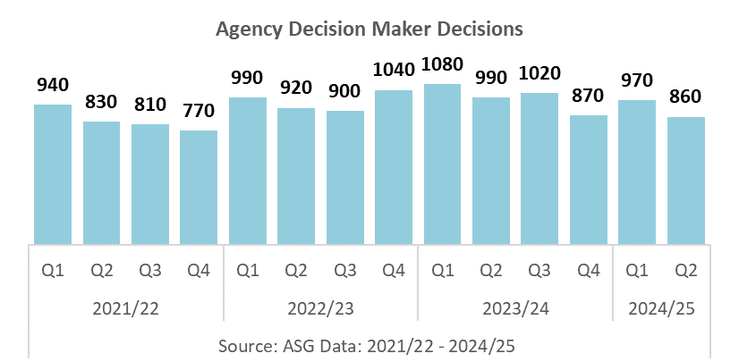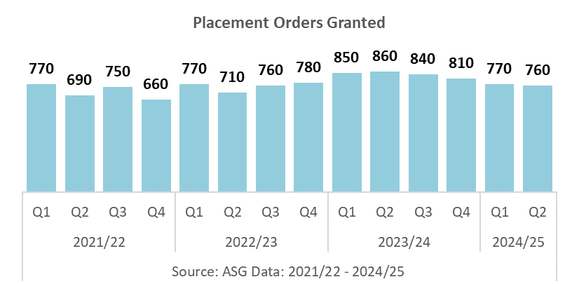

* **360**ADM reversals in total for Q1 and Q2, **46%** of the total for 2023/24
* **28%** of reversals were due to ‘Child’s needs changed’, **34%** ‘Court did not make a PO’, **9%** ‘Adopters cannot be found’, and **29%** were due to ‘Any other reason’

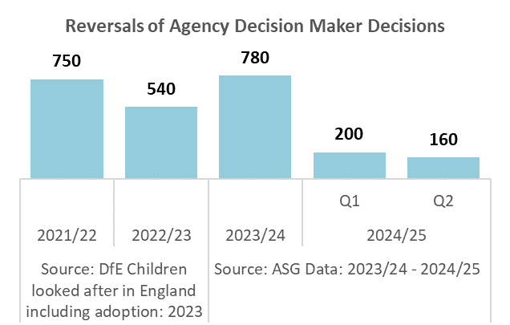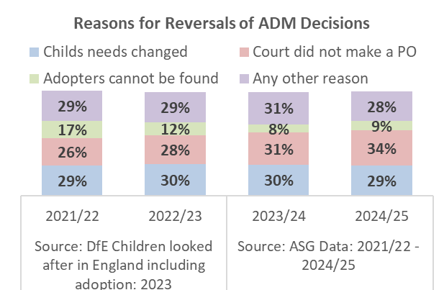

The numbers of Adoption Orders granted decreased, and the number of Special Guardianship Orders granted increased when compared to the last quarter. Total permanence was slightly lower when compared to last quarter.

In Q2 2024/25 there were:

* **760** Adoption Orders granted, a decrease of **6% (5*0n***) from Q1 2024/25, and an increase of **4% *(30n)*** when compared to Q2 2023/24
* **1070** Special Guardianship Orders granted, an increase of **4% *(40n)*** from Q1 2024/25, and an increase of **9% *(90n)*** when compared to Q2 2023/24
* **1830** total permanence orders granted (AOs & SGOs), a decrease of **1% *(10n)*** from Q1 2024/25, and an increase of **7% *(120n)*** when compared to Q2 2023/24
* SGOs accounted for **58%** of all permanence, an increase of **2** percentage point when compared to 2023/24
* **260** children were placed in an FFA/CP arrangement in Q1 and Q2, **47%** of the total for 2023/24

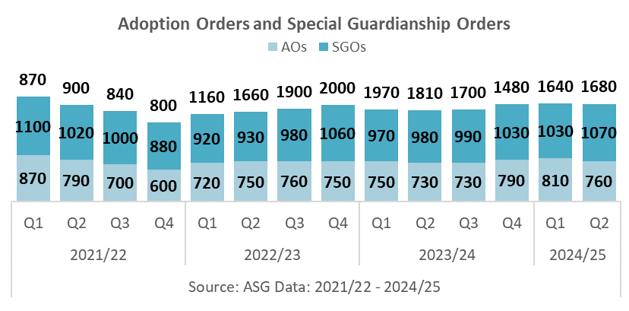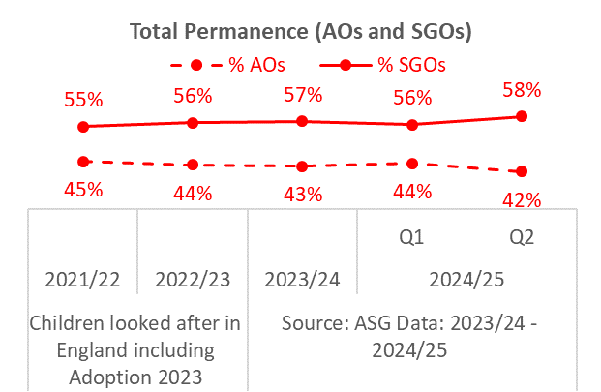

The number of children waiting with a Placement Order, and waiting longer has increased.

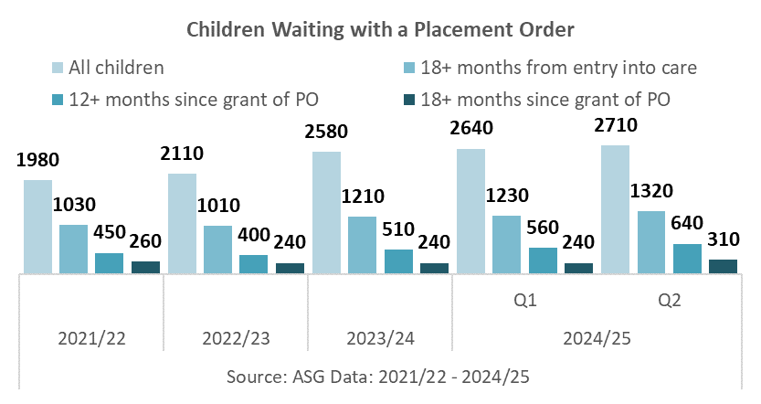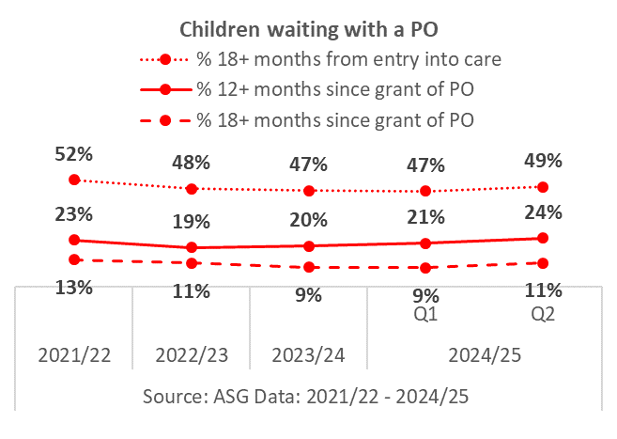

In Q2 2024/25 there were:

* **2710** children with a PO waiting to be placed, an increase of **3%** ***(70n****)* from Q1 2024/25
* **1320** children with a PO waiting to be placed 18+ months since entering care, an increase of **7% *(90n)*** from Q1 2024/25
* **49%** of children with a PO have been waiting to be placed 18+ months since entering care
* **640** children with a PO waiting to be matched 12+ months since grant of PO, an increase of **14% *(80n)*** from Q1 2024/25
* **24%** of children with a PO have been waiting to be matched 12+ months since grant of PO
* **310** children with a PO waiting to be matched 18+ months since grant of PO, an increase of **29% *(70n)*** from Q1 2024/25
* **11%** of children with a PO have been waiting to be matched 18+ months since grant of PO

The number of children matched with an adoptive family increased, and the number of children placed with an adoptive family decreased this quarter.

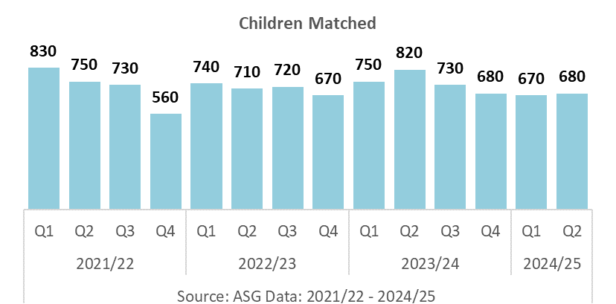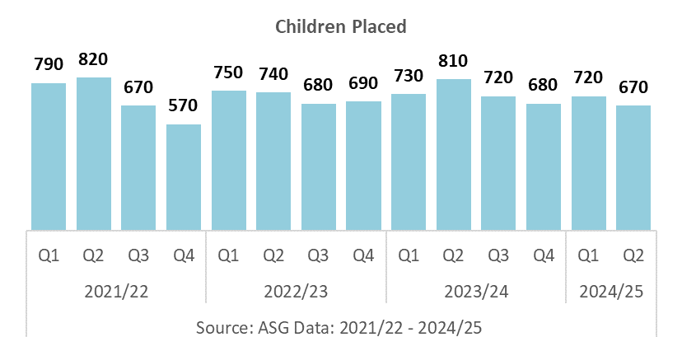

In Q2 2024/25 there were:

* **680** children matched with an adoptive family, an increase of **1% *(10n)*** from Q1 2024/25, and a decrease of **17% *(140n)*** when compared to Q2 2023/24
* **670** children placed with an adoptive family, a decrease of **7%** **(*50n)*** from Q1 2024/25, and a decrease of **17% *(140n)*** when compared to Q2 2023/24

Timeliness has slowed for children.

In Q2 2024/25 there were

* The average number of days spent waiting to be placed with Placement Order since entering care was **622 days**, an increase of **14 days** from Q1 2024/25
* Scorecard Indicator A10 (average number of days between a child entering care and moving in with its adoptive family adjusted for foster care adoptions) was **484 days**, an increase of **8 days** from Q1 2024/25
* Scorecard Indicator A2 (average time between an LA receiving court authority to place a child and deciding on a match to an adoptive family) was **198 days**, an increase of **2 days** from Q1 2024/25
* Scorecard Indicator A20 (average time between a child entering care and an LA receiving court authority to place a child) was **364** days, the same as last quarter

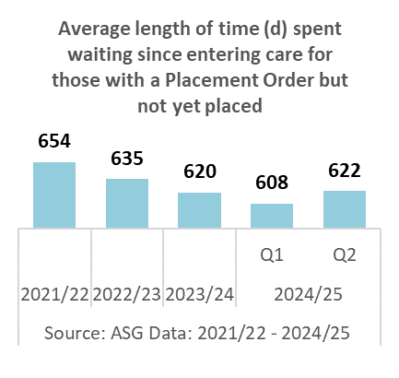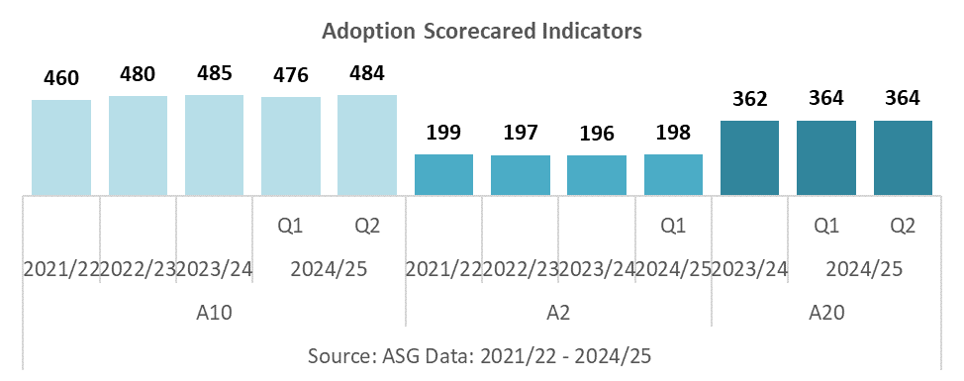

For the first two quarters of 2024/25 there were:

* **720** children with HTP characteristics adopted, **46%** of all children adopted
* **1610** children with HTP characteristics waiting with a PO, **61%** of all children waiting with a PO
* **950** children with HTP characteristics waiting with a PO 18+ months since entering care, **77%** of all children waiting with a PO 18+ months since entering care
* **490** children with HTP characteristics waiting 12+ months since grant of PO, **88%** of all children waiting 12+ months since grant of PO
* **200** children with HTP characteristics waiting 18+ months since grant of PO, **83%** of all children waiting 18+ months since grant of PO

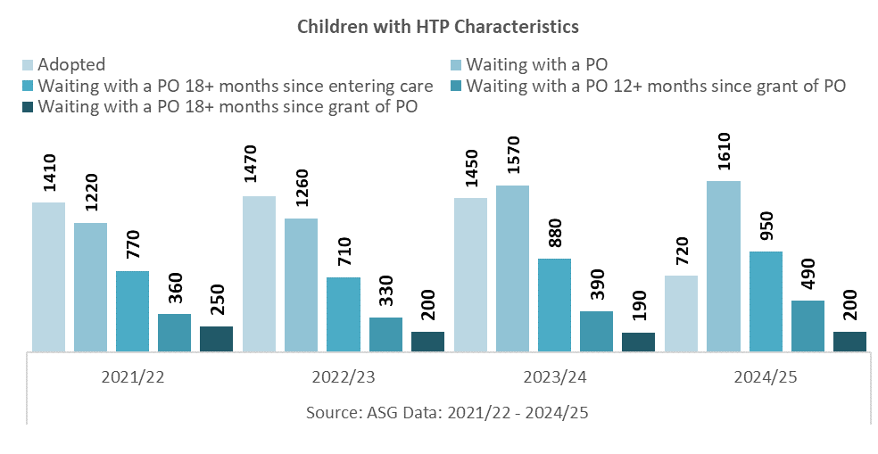

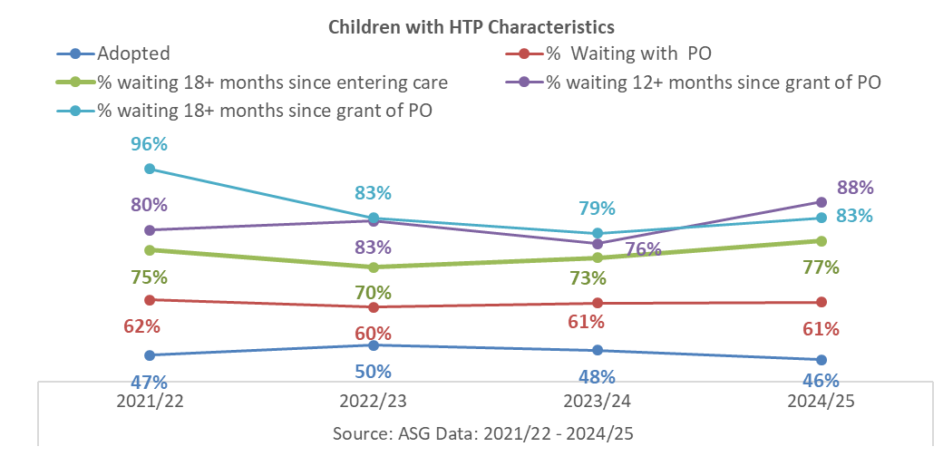

The charts below give a breakdown of the number of children waiting with a PO, and adopted by characteristics.

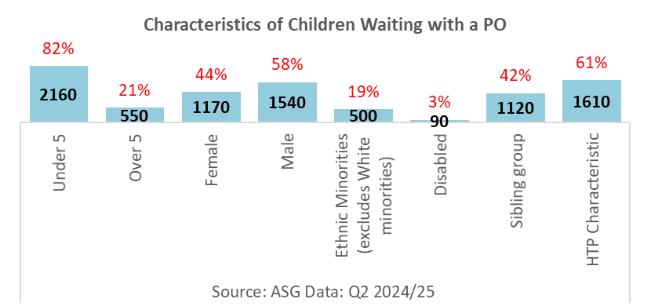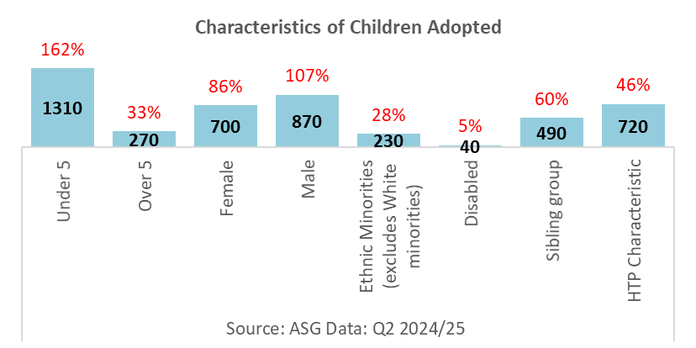

In Q2 2024/25 there were

* Children who were aged under 5, female and not from an Ethnic Minority (excludes White minorities) background continue to be more likely to be adopted and less likely to be waiting with a PO
* Children aged over 5, male, from an Ethnic Minority (excludes White minorities) background, with a disability and in a sibling group continue to be more likely to be waiting with a PO and less likely to be adopted

*NB: "Harder to place" is defined as a child who is any of the following: 5 years or over, with an Ethnic Minority (excludes White minorities) background, disabled, or part of a sibling group. Children with more than one harder to place characteristic will be counted in each characteristic.*

**CHILDREN’S TIMELINESS BY CHARACTERISTIC**

In 2024/25, the average time from entry into care to waiting with a PO as at Q2 for all children was **622** days, **7** days longer than Q1 2024/25. Children aged 5 year and over waited the longest; **884** days, followed by children with a disability: **836** days, and Ethnic Minority children: **710** days.

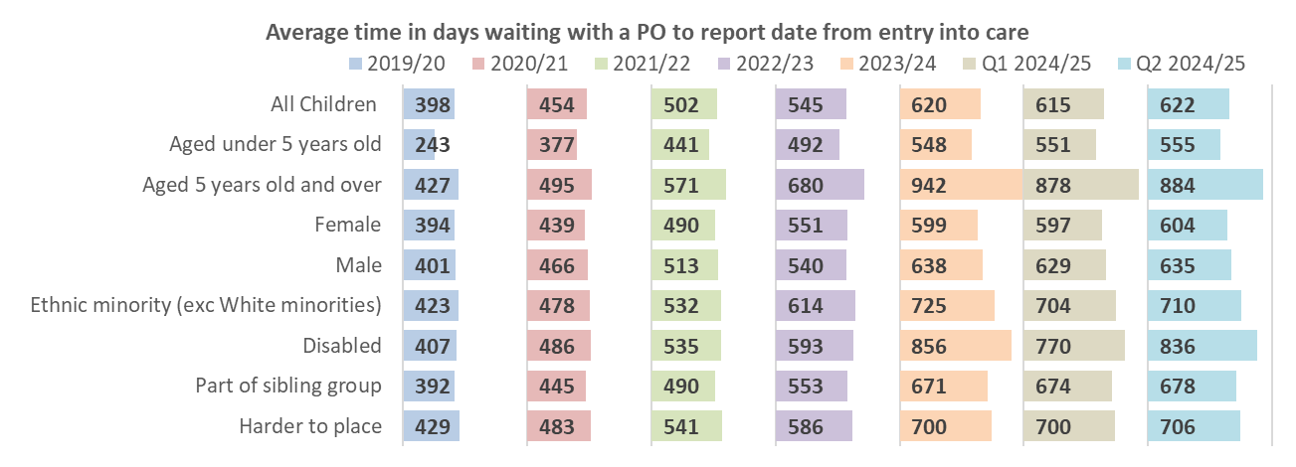

The average time from grant of PO and waiting as at Q2 for all children was **267** days, **12** days longer than Q1 2024/25. Children aged 5 year and over waited the longest since grant of PO; **466** days, followed by children with a disability: **432** days, and Ethnic Minority children: **317** days.

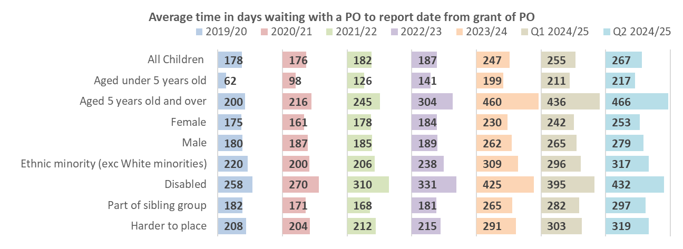

The average time from entry into care to adoption for all children was **841** days, **4** days less than Q1 2024/25. Children aged 5 year and over had the longest journey to adoption; **1273** days, followed by children with a disability: **1222** days, and children in a sibling group: **990** days.

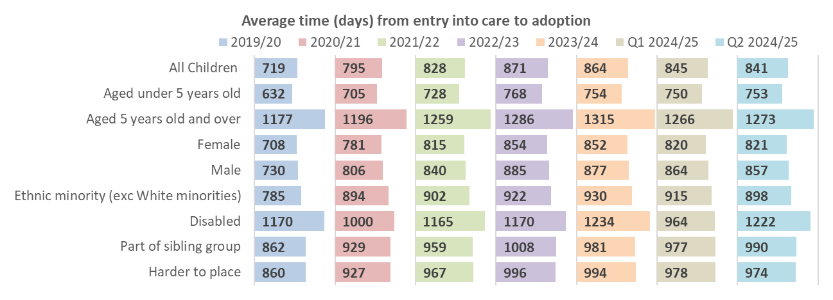

**SPECIAL GUARDIANSHIP ORDERS**

The number of Special Guardianship Orders granted in Q2 2024/25 increased when compared to the last quarter. More children leave care with an SGO than an adoption order, with SGOs accounting for **58%** of all permanence.

In Q2 2024/25, there were:

* **1070** SGOs granted, an increase of **4% *(50n)*** from Q1 2024/25, and an increase of **9% *(90n)*** when compared to Q2 2023/24
* **51%** of the children were male, **48%** female, **6%** had a disability, **19%** were from an Ethnic Minority (excluding White minorities), and **45%** were in a sibling group

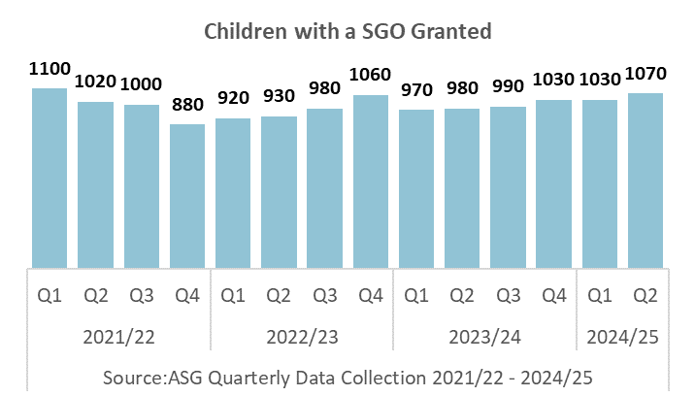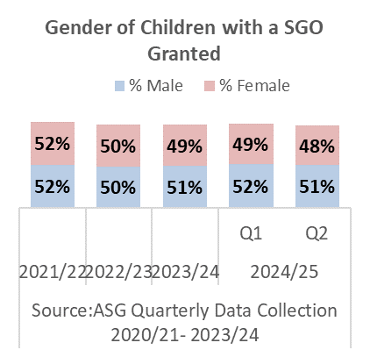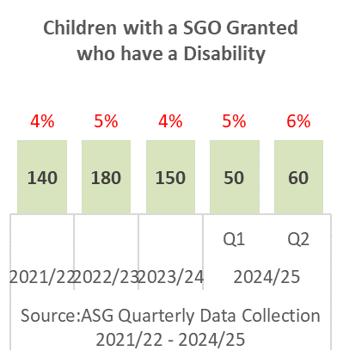

Children aged 1 to 4 are the largest group of children who leave care with an SGO ***(34%)***, followed by children aged 5 to 9 ***(26%)***

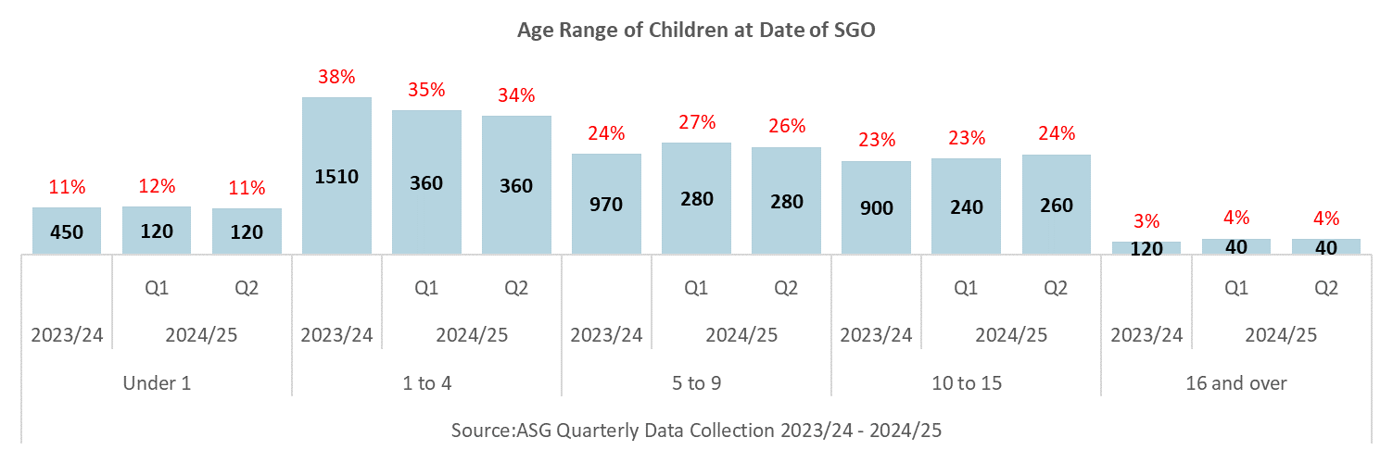

* **19%** of SGOs were granted for children from an Ethnic Minority (excludes White minorities, with children with a Mixed Ethnicity are the biggest represented Ethnic Minority

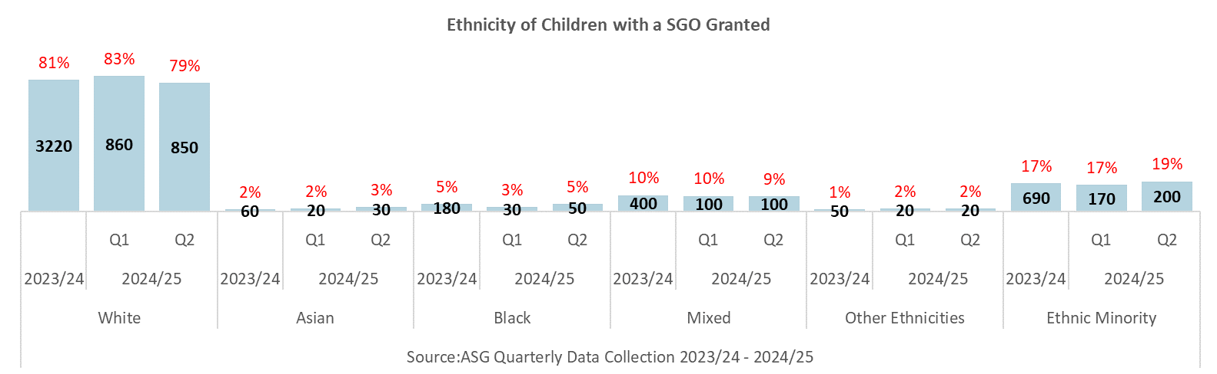

* Children not in a sibling group continue to be the largest group of children who leave care with an SGO **(55%)**, followed by children in a sibling group of 2 **(24%)**

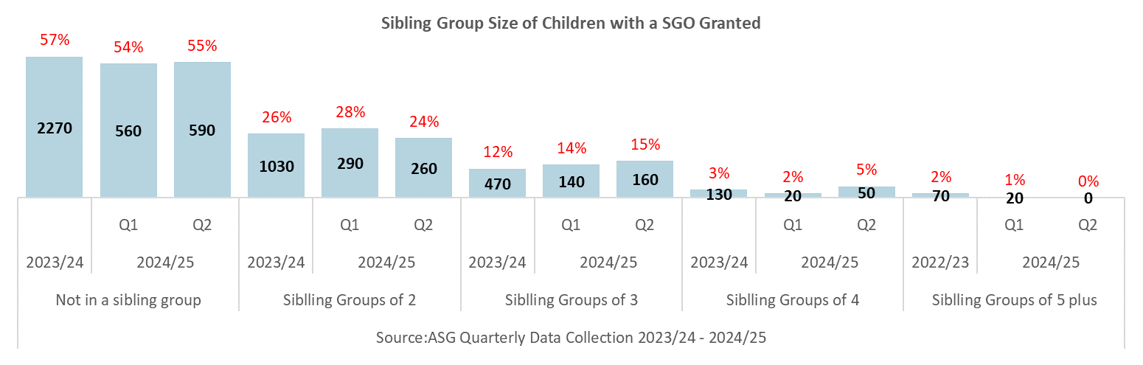

* Grandparents are the largest represented group of Special Guardians, with **52%** of SGOs granted to grandparents, followed by other family relatives **(31%)**

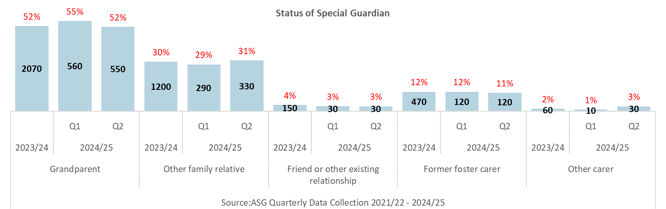

* Special Guardians aged 50 to 59 are the largest represented age group **(30%)**, followed by and special guardians aged 40 to 49 **(25%)**

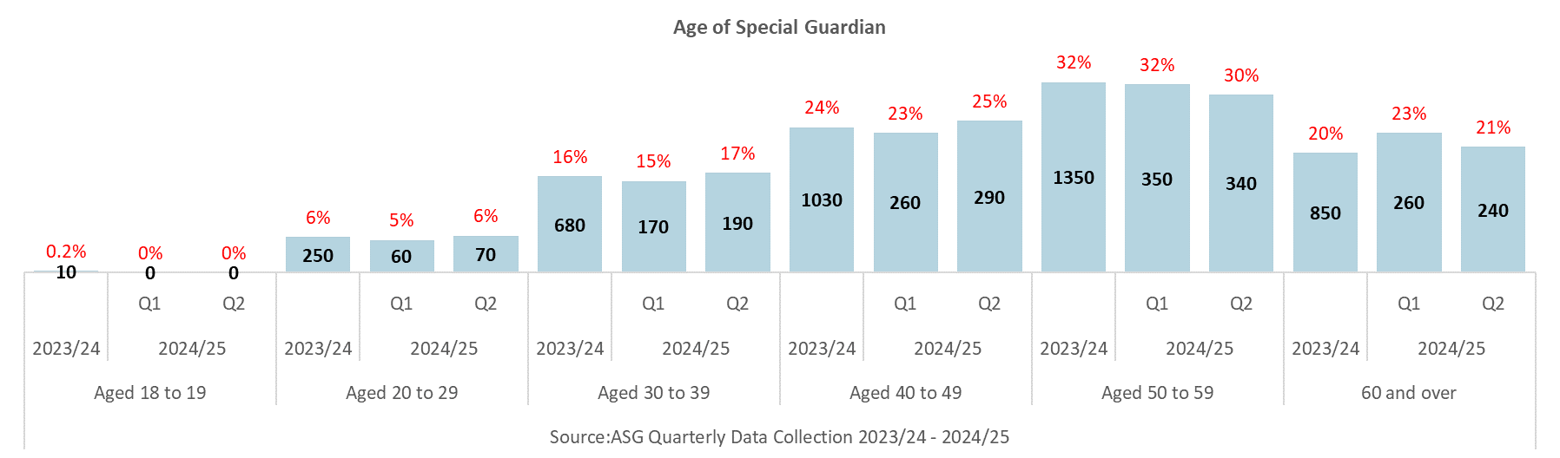

**ADOPTERS**

Adopter recruitment continues to decline, reducing the number of available approved adoptive families to be matched with the children waiting with a PO.

In Q2 2024/25 there were:

* **710** Registrations, a decrease of **12%** (***100n***) from Q1 2024/25, and a decrease of **8% *(60n)*** when compared to Q2 2023/24
* **530** Approvals, an increase of **8%** **(4*0n)*** from Q1 2024/25, and a decrease of **4% *(20n)*** when compared to Q2 2023/24

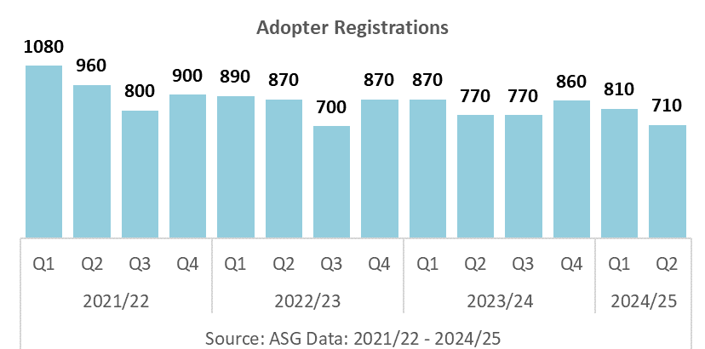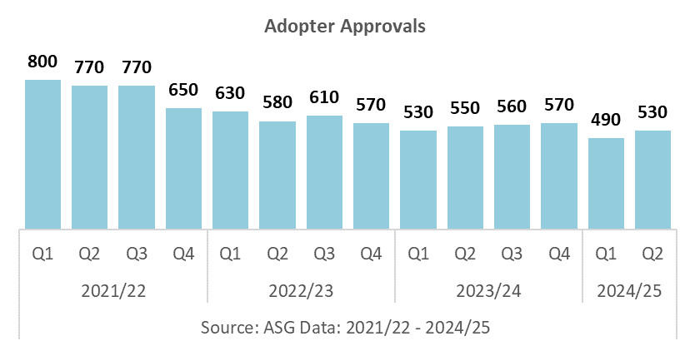

* **2170** Prospective adoptive families not yet approved, a decrease of **2%** (***50n***) from Q1 2024/25
* **1550** Approved adoptive families waiting to be matched, a decrease of **4%** (***60n***) from Q1 2024/25
* **140** approved adopters withdrew from the process after approval in Q1 and Q2, **47%** of the total for 2023/24

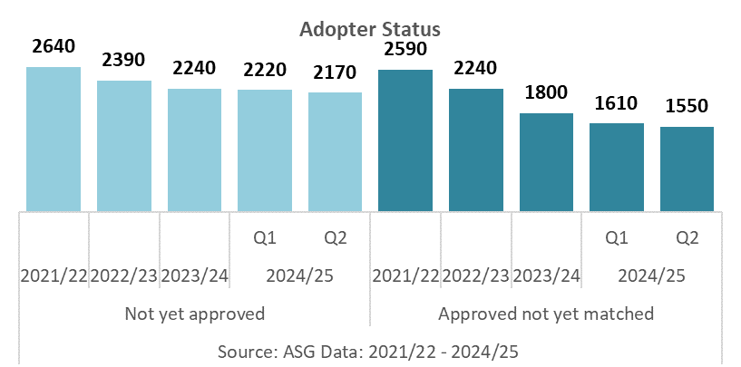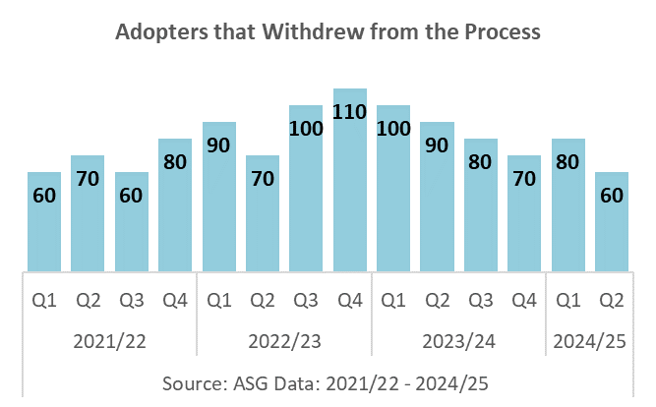

The number of adopters being matched with a child, and having a child placed with them were lower this quarter.

In Q2 2024/25 there were:

* **540** Adoptive families matched to children, a decrease of **4% *(20n)*** from Q1 2024/25, and a decrease of **14% *(90n)*** when compared to Q2 2023/24
* **520** Adoptive families with a child placed, a decrease of **10% *(60n)*** from Q1 2024/25, and a decrease of **19% *(120n)*** when compared to Q2 2023/24

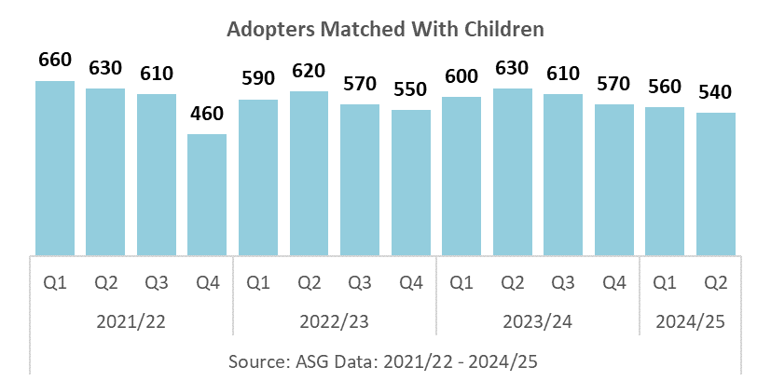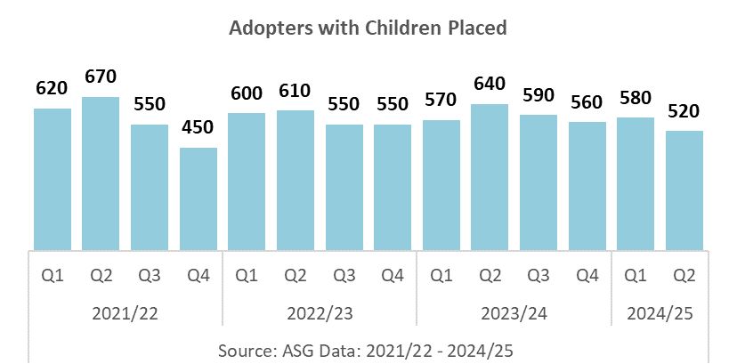

A higher proportion of adopters were approved within 6 months of registrations, and a lower proportion of adopters were matched within 3 months of approval.

In Q2 2024/25 there were

* **23%** of adoptive families were approved within 6 months of registration, an increase of **1** percentage point when compared to Q1 2024/25
* **23%** of approved adoptive families had a child matched with them within 3 months of approval, a decrease of **2** percentage points when compared to Q1 2024/25

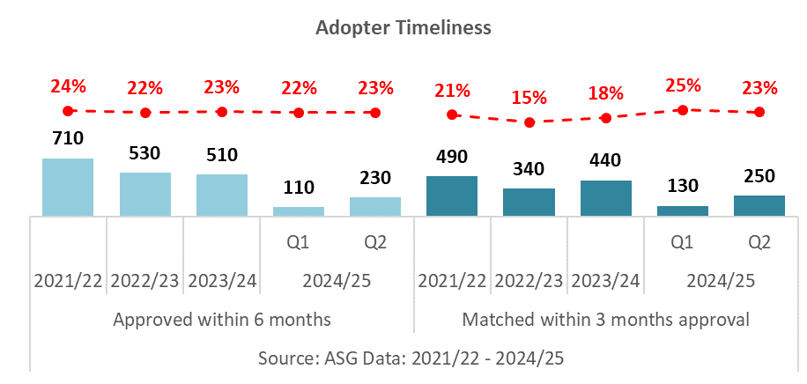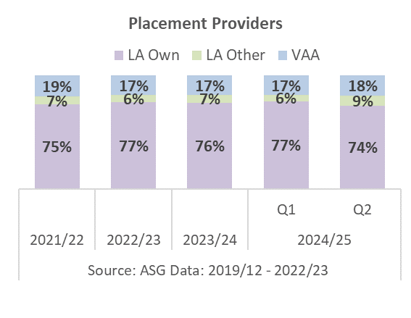

There has been an increase in the proportion of VAA placements and placements to other LAs, and a decrease in the proportion of children placed with LAs own adopters via their RAAs.

In Q2 2024/25 there were

* **74%** of placements were provided by LAs themselves (via their RAAs)
* **9%** of placements were provided by other LAs (other RAAs)
* **18%** of placements were provided by VAAs

*NB: Percentages may not add due to rounding of numbers*

**SUFFICIENCY OF ADOPTERS**

Adopter Recruitment is declining, reducing the number of approved adopters available for the children waiting with a PO. This quarter there has been a decrease in adopter registrations, prospective adopters not yet approved, and adopters approved and waiting, and an increase in the number of adopter approvals.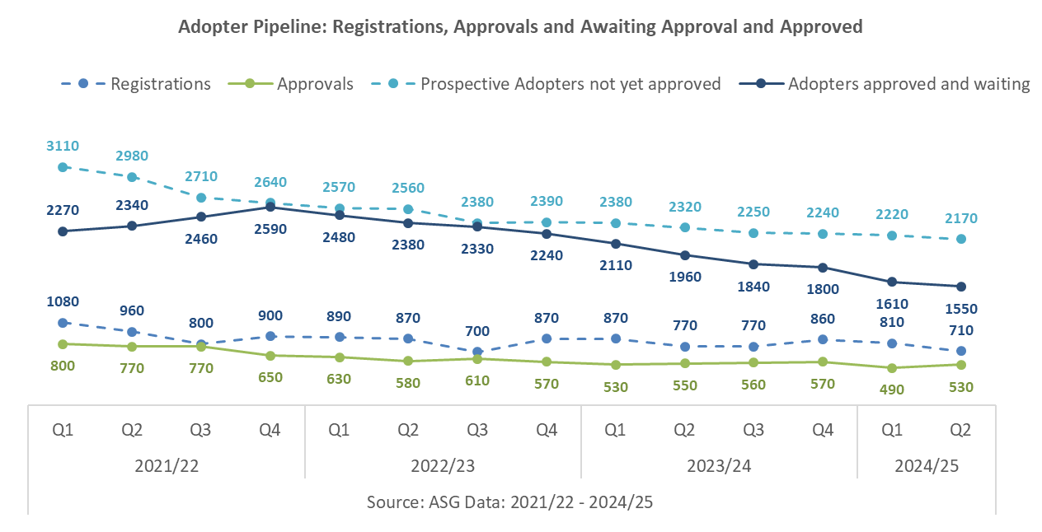

Adopter sufficiency continues to decline, with more children waiting with a PO to be placed with a family than approved adopters waiting. There are more POs granted each quarter than adopters approved, resulting in a higher number of children reaching the matching stage compared to adopters.

In Q2 2024/25 there were:

* **2710** children waiting with a PO not yet placed, and **1550** approved adopters waiting for a child to be placed; a gap of **1160**
* **760** POs granted, and **450** adopter approvals; a gap of **310**

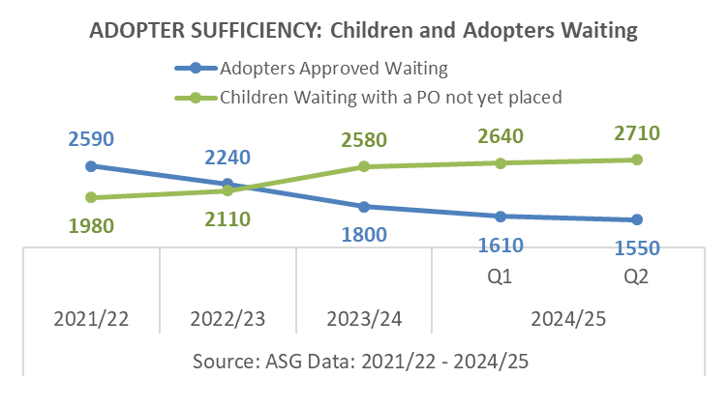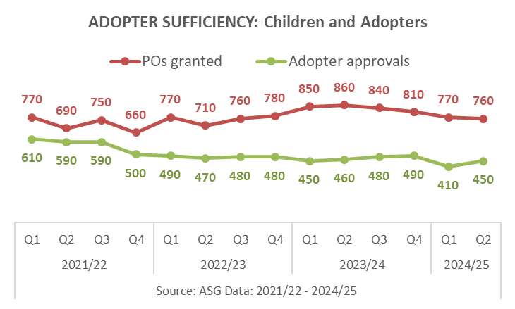

Comparison of the family finding status for all children and all adopters waiting show that there are:

* **1710** children with active family finding
* **1310** adopter families need *(based on the number of single children and sibling groups waiting to be placed)*
* **720** adopter families with active family finding
* **590** shortfall of adopter families
* **55%** adopter sufficiency (proportion of families available for families needed)

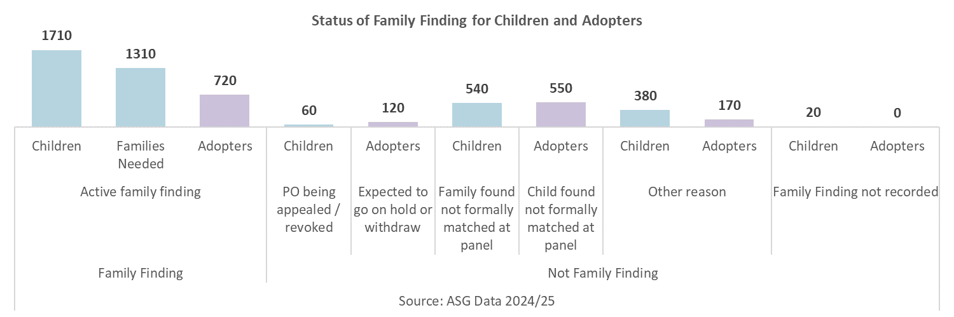

**DATA SOURCES**

**ASG Quarterly Data Collection**

In quarter 2 2024/25 the response rate from local authorities for the child level section was 99.3*% (1 LA was unable to submit their child level data return)*, and the adopter level sections was 100%. The response rate for the adopter level section from Voluntary Adoption Agencies was 100%. Therefore, national and regional figures on adoptions and adopters do not include estimates made for non-responses.

**SSDA 903 Data Collection**

Local authorities provide data on their looked after children using the SSDA903 collection. Data are collected from all local authorities. The information is collected at child level and includes information about the child’s characteristics and their dates for each stage of the care process, including adoption. The data goes through thorough quality assurance and local authorities are able to update their historic data annually. We therefore view this as the most robust source of information on adoption. It is used to produce the [Children looked after in England including adoption](https://www.gov.uk/government/collections/statistics-looked-after-children) (SFR). The most recent data covers the year ending 31 March 2023.

**ABOUT THIS PUBLICATION**

This publication was produced by The Children and Social Care Secretariat, delivered by Coram-i on behalf of the Department for Education.

download: [ASG Quarterly Data](https://www.coram.org.uk/the-childrens-and-social-care-secretariat/)

email: [asglb@coram.org.uk](mailto:asglb@coram.org.uk)

write: Coram Coram Campus, 41 Brunswick Square, London WC1N 1AZ