We want to hear what you think!

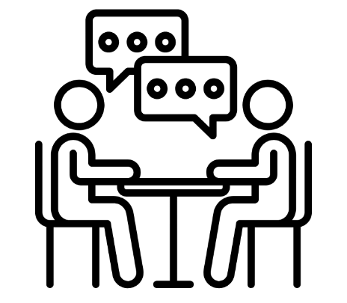
What do we want to talk about?
We want to talk with you about your life and family.
We want to find out what it is like when you live with someone who is not your parent, like a grandparent or aunty.
It is up to you if you want to talk to us!

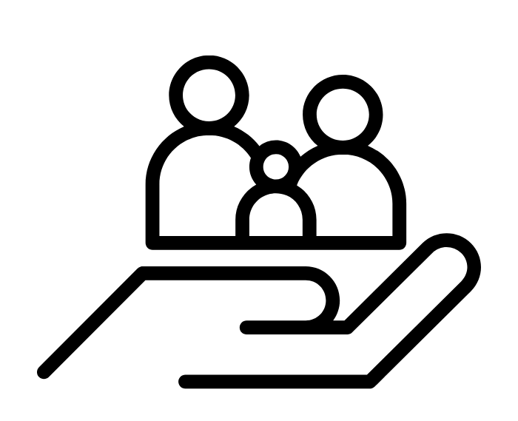
Who is it with?
You will be talking with a researcher from Coram, a charity that helps children and young people.

What will we talk about?
We might talk about things like:
- what matters most to you in life
- what makes you feel happy or supported
- people who are important to you
- things you enjoy
- things you would like to change.
You don’t have to answer our question. You can say ‘stop’ or ‘I don’t want to talk about that’ at any time.

Why do we want to talk with you?
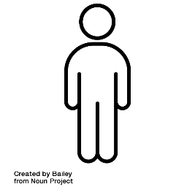
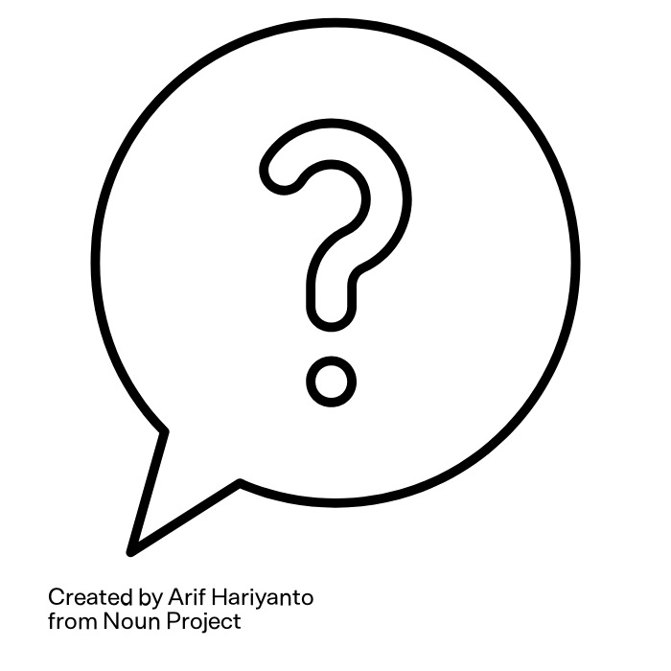
We want to learn about what it’s like for you to live in kinship care.

We want to hear your ideas about what helps you and what could make life better for children like you.

There are no right or wrong answers. We just want to hear what you think.

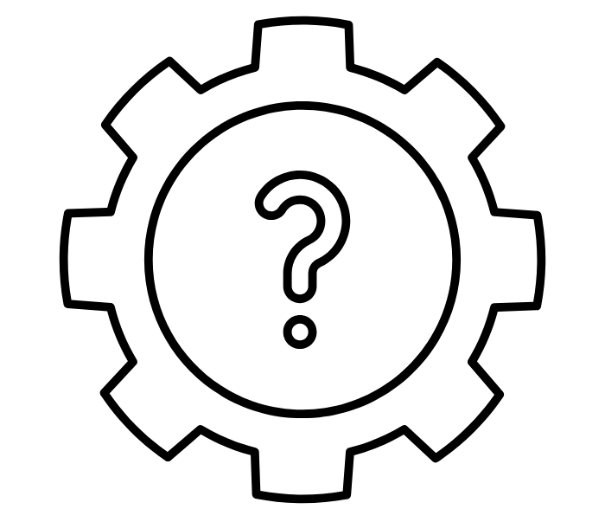
How will it work?
You can choose:
- a one-to-one chat, or
- a small group discussion with other children your age

You can also choose if it is:
- in person (like at school or a youth centre) or online

We will do fun activities like drawing, using pictures, or objects to help you share your ideas.

You can stop whenever you like. It’s okay if you just want to draw. I might ask you some questions about your drawing.

You will get a thank-you voucher for taking part.

Recording the discussion

We might record the session so we don’t forget what you say. Your name or anything that could identify you will not be shared.

We will keep the recording safe and private. We will delete it after the report is finished. We won’t share it with anyone outside Coram.
If you don’t want to be recorded, that is fine as well!


Keeping the discussion private
Your chat with us is private. We won’t tell anyone outside the research team what you say. If you are aged 15 and under, we will ask your parent or guardian if it is ok if we speak with you. However, we will not tell them what we have spoken about.
The only time we would share what you say is if we think you or someone else is not safe. If this happens, we will talk to you about how we are going to share what you have said.
Anything you have told us will be anonymous. This means that your name or any details about you will not be included in the report. No one will know that the information is about or from you.

What will we do with what you tell us?

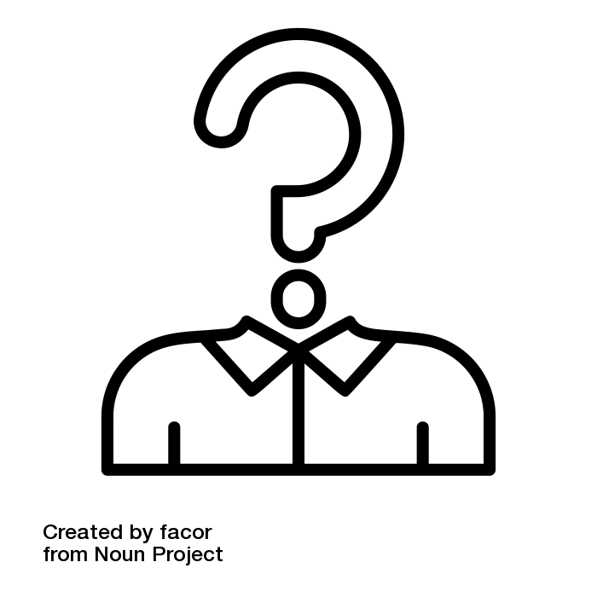
We will use your ideas to help adults understand what matters to children in kinship care. We won’t use your name. Your ideas will be mixed with other children’s ideas.
The report will be shared with the government. It might also appear on the Coram website or in the news.
We can share the report with you if you would like to see it.
Even after we have spoken, you can ask that all or parts of our conversation are not in the report. Just let us know before 30 August 2026.

Could it be upsetting for me to take part?

We know talking about family can be nice but also sometimes hard or upsetting.
You do not need to answer any of our questions if you don’t want to, and we can take a break or stop at any time.
We will be kind and supportive. We can also tell you about other places to get help if you need it.

Are you happy to take part?

If you are happy to take part, that’s great news! Tell your parent or carer. They can contact us by email, phone or WhatsApp to arrange a time to chat.
If you are over 16 years old, you can get in touch with us yourself!
We also need you to complete the agreement on the next page. We can do this when we meet or you or your parent or carer can send it to research@coram.org.uk. The agreement is between you and the Coram researcher to make sure you feel happy to take part – remember you can always say you do not want to take part at any time!

How to contact us

We are always happy to answer any questions you have. You can contact us by:

Calling, texting or WhatsApp messaging: 07805 813071
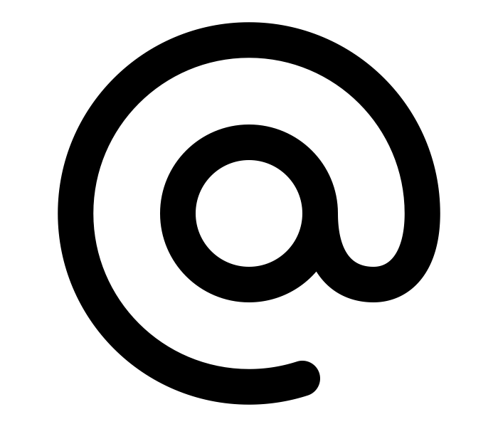
Calling: 020 7520 0365 (Mon to Fri, 9am to 5pm) and asking for Mia

Emailing: research@coram.org.uk
Writing to: Coram Impact & Evaluation, 41 Brunswick Square, London WC1N 1AZ



Agreement form between you and the researcher
Please circle ‘Yes or ‘No’ for each statement:
Remember, you can always circle ‘No’!

For you:
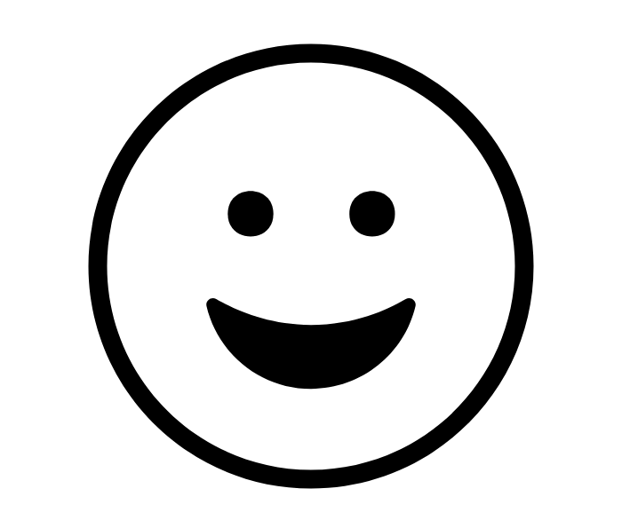 | I am happy to take part in a discussion about family and my life | Yes | No
a
 | I am happy for the conversation with the Coram researcher to be audio recorded | Yes | No
a
 | I understand that what I say will be private (not discussed with anyone outside the Coram research team) unless a Coram researcher has concerns about someone’s safety | Yes | No
a
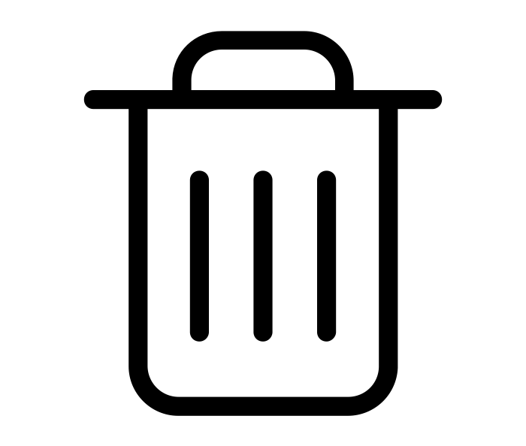 | I understand that I can ask to have what I have said removed from the research even after taking part by 30 August 2026 using Coram contact details above | Yes | No

Please write your name:
Please write today’s date:

For the Coram researcher
 | I will treat you with kindness and respect and if at any point you say you are not happy to take part in the research and we will stop immediately | Yes | No
a
 | I will only audio record you talking if you feel ok to do this | Yes | No
a
 | I will keep your information and what you say safe and private (not discussed with anyone outside the Coram research team) unless I have concerns about someone’s safety | Yes | No
a
 | I will remove what you say from the research even after you take part if you let me/Coram know by 30 August 2026 | Yes | No

Please write your name:
Please write today’s date:

