Adoption and Special Guardianship Quarterly Data Collection

Headline Measures: Q1 2026/27

September 2026

Note: The Department for Education’s annual figures on adoptions and timeliness for children who have been adopted are published in the Children looked after in England including adoption report. This is the most robust source of information on adoption.

EXECUTIVE SUMMARY

OVERALL PICTURE
The results indicate a continued pressure on adopter sufficiency. In Q1 2026/27, slightly fewer children waited for adoption, but waited for longer periods of time, when compared to the previous quarter, while adopter family registrations and approvals have declined. However, the trends in adoption were not all uniformly negative: the average time taken for a child to move from entry into care to adoption decreased, and the proportion of adopter families matched within three months of approval increased.

KEY FINDINGS FOR Q1 2026/27

Children and permanence
The adoption and court order figures were lower in Q1 2026/27. When compared to 2025/26:
- Court issued orders decreased compared to the previous quarter (Q4 2025/26) and Q1 2025/26.
- Whilst there were 790 Agency Decision Maker (ADM) decisions to place a child for adoption (a decrease of 4% compared to Q4 2025/26, so far ADM reversals came to 240, approximately a quarter (24%) of the total recorded for the reporting year 2025/26.
- The number of Placement Orders (POs) granted decreased by 6% to 620, also a decrease of 23% compared to Q1 2025/26; the number of Adoption Orders (AOs) decreased by 11% to 620 compared to Q4 2025/26, also a decrease of 14% compared to Q1 2025/26.
- The number of children with a PO waiting to be placed decreased by 1% to 2,970 compared to the end of 2025/26. Of these, 1,570 had been waiting for 18 months or more since entering care, an increase of 1%.
- Children with harder to place (HTP) characteristics remained over-represented among those waiting and continued to wait longer on average, broadly increasing from the end of last reporting year. 270 of these children were adopted, so far, just over a fifth (22%) of the annual total for 2025/26. The number of children with HTP characteristics waiting with a PO decreased by 3% to 1,740 compared to last quarter. These children accounted for 59% of all children waiting with a PO.
- Timeliness outcomes were mixed. For children with a PO still waiting to be placed, the average time spent waiting since entry into care increased from 646 days (by 6 days) to 652 days when compared to 2025/26. Scorecard indicator A2 was 237 days, 15 days longer than at the end of 2025/26, which equalled 222 days, and, Scorecard indicator A20 was 305 days, 19 days shorter than last quarter (286 days). The average journey from entry into care to adoption fell by 14 days, from 816 days to 802 days.

Special Guardianship Orders (SGOs)
There were 970 SGOs granted in Q1 2026/27, the same as last quarter, however this was a slight decrease of 1% compared to Q1 2025/26. The overall profile of children and special guardians remained broadly stable: children aged 1 to 4 remained the largest child age group, while grandparents continued to account for the majority of special guardians.

Adopters and sufficiency
Most adopter activity measures decreased in 2025/26 when compared to the previous quarter, with exception of adopter families matched and placed, prospective families not yet approved all increased. When compared to Q4 2025/26:
- Both registrations and approvals decreased. There were 770 registrations in Q1 2026/27, a 7% decrease. There were 470 approvals, a decrease of 16%. The number of prospective adopter families not yet approved was 2,190, an 8% increase compared to last quarter, while the number of adopters approved and waiting to be matched was 1,350, a decrease of 4% compared to last quarter.
- The number of children with a PO waiting to be placed was 2,970 children. When compared with 1,350 approved adopter families waiting, this shows a numerical difference of 1,620.
- An estimated 1,580 adopter families were required for children compared to only 640 approved adopter families actively in family finding. This equates to a shortfall of 940 adopter families.

CONTENTS
EXECUTIVE SUMMARY 2
OVERALL PICTURE 2
KEY FINDINGS FOR Q1 2026/27 2
CONTENTS 4
GLOSSARY 5
REPORTING NOTES 6
CHILDREN 6
DECISIONS FOR CHILDREN 6
CHILDREN WAITING 9
CHARACTERISTICS OF CHILDREN WAITING AND ADOPTED 12
CHILDREN’S TIMELINESS BY CHARACTERISTICS 14
SPECIAL GUARDIANSHIP ORDERS (SGOs) 16
CHARACTERISTICS OF CHILDREN 16
CHARACTERISTICS OF SPECIAL GUARDIANS 20
ADOPTERS 23
RECRUITMENT AND PROGRESSION 23
ADOPTER TIMELINESS 26
PLACEMENT PROVIDERS 26
FAMILY FINDING AND WITHDRAWALS 27
SUFFICIENCY OF ADOPTERS 28
ADOPTER PIPELINE 30
PIPELINE BALANCE 31
CONCLUDING REMARKS 32
DATA SOURCES 33
ASG QUARTERLY DATA COLLECTION 33
DfE SSDA 903 DATA COLLECTION 33
ABOUT THIS PUBLICATION 33

GLOSSARY
Terms and abbreviations used in this report are defined below.

TERM | DEFINITION | TERM | DEFINITION
ADM | Agency Decision Maker: the senior decision-maker who confirms whether adoption should be the plan for a child. | A10 | Average time from entry into care to moving in with the adoptive family, adjusted for foster carer adoptions.
ADM reversal | When an ADM formally cancels an official plan to place a child for adoption. | ASG | Adoption and Special Guardianship quarterly data collection.
A2 | Average time from court authority to place a child to the local authority’s decision on an adoptive match. | DfE | Department for Education.
A20 | Average time from entry into care to the local authority receiving court authority to place the child. | Family finding | The process of identifying and securing a suitable permanent family for a child.
Early permanence | A placement intended to provide continuity while the child’s final adoption plan is still being determined. | LA | Local authority.
HTP | Harder to place: children aged 5 years and over, with a disability, in a sibling group, or from an ethnic-minority group excluding White-minority groups. | RAA | Regional Adoption Agency.
PO | Placement Order: a court order authorising a local authority to place a child for adoption. | VAA | Voluntary Adoption Agency.
SGO | Special Guardianship Order: a court order placing a child with a special guardian and granting enhanced parental responsibility. | Percentage point | The arithmetic difference between two percentages, for example 25% to 20% is a decrease of 5 percentage points.
Adopters/Adopter family | One adopter or an adopting couple, counted as one family. | Suppression | Small counts shown as ‘c’ or ‘S’ rather than a number to protect confidentiality.
Reporting year | The period from 1st April to 31st March. | Timeliness | How long children and adopter families take to reach key stages in the adoption process, measured either in days between specified milestones or as the proportion progressing within a stated period. For children still waiting, it measures time elapsed up to the reporting date, not their eventual completed waiting time.
AO | Adoption Order: a court order that makes an adoption legally permanent and transfers parental responsibility.

REPORTING NOTES
Note on how percentages are reported: This report uses percentage change to describe changes in numbers. For example, adopter registrations fell from 830 to 770, a decrease of 7%; where shown after a comparison, n gives the corresponding numerical change in the rounded count (n = 60). Changes between proportions are expressed in percentage points: for example, a fall from 25% to 16% is a decrease of 9 percentage points. Elsewhere, n indicates the rounded number represented by a percentage.

Note on rounding: Counts shown as n are rounded national totals unless otherwise stated. Counts and percentages are rounded independently; component values may therefore not sum to the displayed total or to 100%. Rounding and suppression for low sub-counts is carried out on all reported figures to ensure anonymity of individuals.

Note on data revision: The ASG figures are based on the data returns available at the time of analysis and remain subject to revision if updated data submissions are received.

Note on comparisons: This report compares the Q1 2026/27 data to previous quarterly data or previous annual data. Where data is rolling, e.g., waiting times at the end of the reporting period, comparisons are made to the previous year end data (which is also the same as he Q4 2025/26 data). Proportional comparisons may also be made between current quarterly data and previous annual data to highlight/track trend continuation or break from the previous annual figures.

CHILDREN
The adoption and permanence figures were lower in Q1 2026/27 compared to the last quarter, Q4 2025/26. Agency Decision Maker (ADM) reversals decreased proportionately compared to the last reporting year, and the number of children waiting with a Placement Order (PO) decreased. Long waits became more common, and children with harder to place (HTP) characteristics remained over-represented among those waiting and continued to wait longer on average.
Timeliness was mixed. The A20 scorecard indicator and the completed journey from entry into care to adoption decreased, while the average time for children still waiting and scorecard indicator A2 increased.

DECISIONS FOR CHILDREN

Change since 2025/26
In the first quarter (Q1) of 2026/27 (ending 30th June 2026), Local Authority (LA) ADM decisions that a child should be placed for adoption decreased compared to last quarter (Q4 2025/26) and Q1 from the last report year (Q1 2025/26). The number of POs granted also decreased (fig. 1). In Q1 2026/27 there were:

- 790 ADM decisions, a decrease of 4% (n = 30) compared to Q4 2025/26, and a decrease of 19% (n = 180) compared to Q1 2025/26
- 620 POs granted, a decrease of 6% (n = 40) compared to Q4 2025/26, and a decrease of 23% (n = 180) compared to Q1 2025/26
- 240 ADM reversals, 24% of the total for 2025/26 (fig. 2)

Among ADM reversals with a recorded reason, the proportion attributed to the court not making a PO was 14% in Q1 2026/27, compared with 16% across the full 2025/26 reporting year, a decrease of 2 percentage points so far this reporting year compared to 2025/26 (fig. 3).

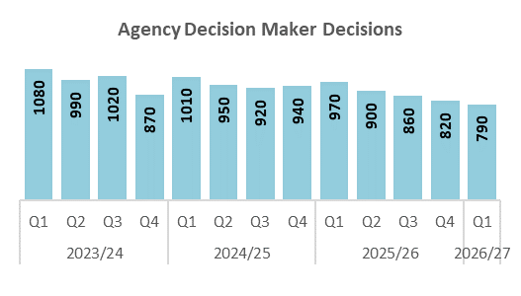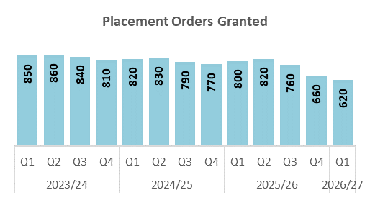
Fig. 1: graph showing changes in ADM decisions and POs for each quarter since 2023/24.

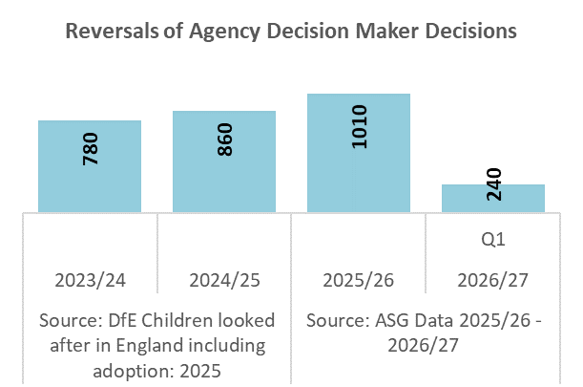
Fig. 2: number of reversals of ADM decisions for this quarter and the previous three reporting years

Fig. 3: reasons given for ADM reversals by percentage for this quarter and the previous three reporting years. Note: 2025/26 and 2026/27 percentages use unique child-level records with a valid reversal reason. Duplicate records and records without a reason code are excluded; consequently, the denominator differs from the rounded national-level total.
In Q1 2026/27, the number of Adoption Orders (AOs) decreased and Special Guardianship Orders (SGOs) remained the same (fig 4, left panel). Compared with Q4 2025/26, there were:

- 620 AOs granted, a decrease of 11% (n = 80). This was also a decrease of 14% (n = 100) compared to Q1 2025/26.
- 970 SGOs granted, the same as last quarter. This was a slight decrease of 1% (n = 10) compared to Q1 2025/26.
- 1,590 permanence orders (AOs and SGOs, not including ROs and CAOs) in total, a decrease of 5% (n = 80).
- SGOs continued to outnumber AOs and accounted for 61% of permanence orders (fig 4., right panel).

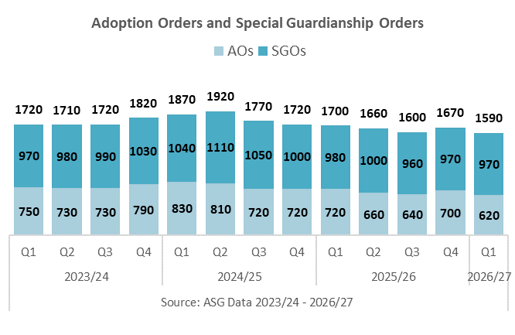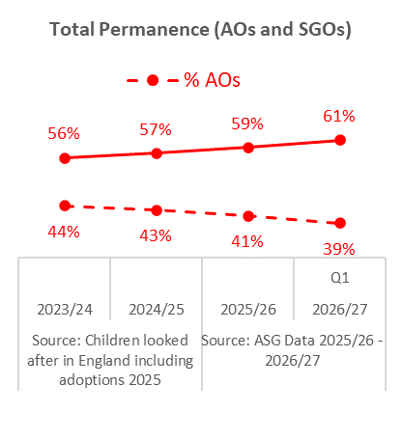
Fig. 4: left panel shows the number of AOs and SGOs granted each quarter since 2023/24; right panel shows the proportion of the total permanence orders recorded that are AOs and SGOs. Note: Data on Residence Orders and Child Arrangements Orders are not collected in the ASG collection.

In Q1 2026/27, the number of children matched increased (fig. 5) and the number of children placed (fig. 6) with an adopter family increased and decreased. Compared with Q4 2025/26, there were:
- 570 children were matched with an adopter family, an increase of 10% (n = 50). In contrast, this was a decrease of 16% (n = 110) when compared to Q1 2025/26.
- 560 children were placed with an adopter family, a decrease of 3% (n = 20). This was also a decrease of 15% (n = 100) when compared to Q1 2025/26.

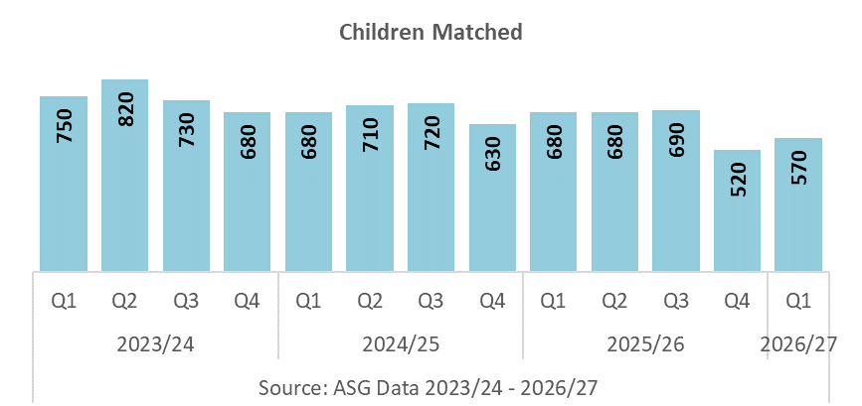
Fig. 5: the number of children matched with an adopter family each quarter since 2023/24
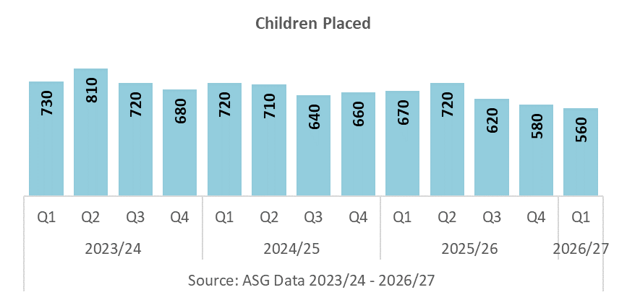
Fig. 6: the number of children placed with an adopter family each quarter since 2023/24

CHILDREN WAITING

Change since Q4 2025/26
Timeliness outcomes were mixed. Whereas, the average time for children waiting with a PO increased, as did scorecard indicator A2,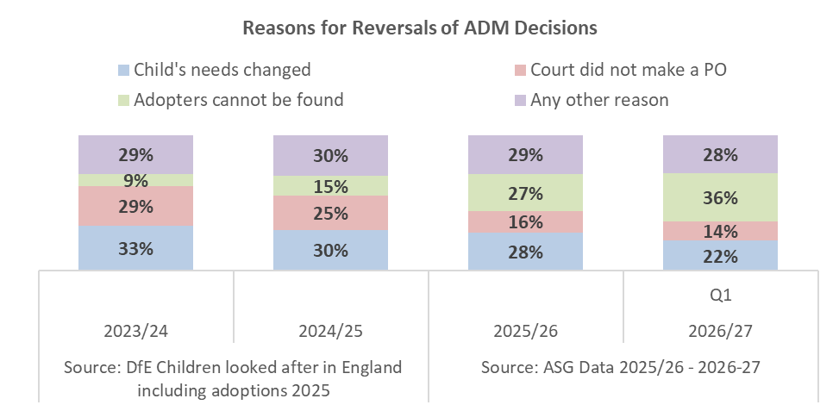
A10 and A20 decreased. Compared with Q4 2025/26:
- The average time since entry into care for children waiting with a PO was 652 days, 6 days longer than in Q4 2025/26 (fig. 7)

- Scorecard Indicator A10, the average time between a child entering care and moving in with their adoptive family, adjusted for foster carer adoptions, was 457 days, 23 days shorter than Q4 2025/26 (fig. 8)

- Scorecard Indicator A2, the average time between a local authority receiving court authority to place a child and deciding on a match with an adoptive family, was 237 days, 15 days longer than Q4 2025/26 (fig. 8)

- Scorecard Indicator A20, the average time between a child entering care and a local authority receiving court authority to place them, was 305 days, 19 days shorter than Q4 2025/26 (fig. 8)

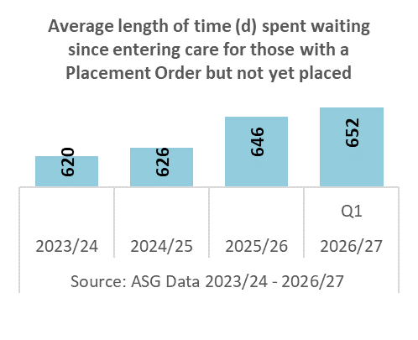
Fig. 7: average time since entry into care for children waiting with a PO for this quarter and the previous three reporting years

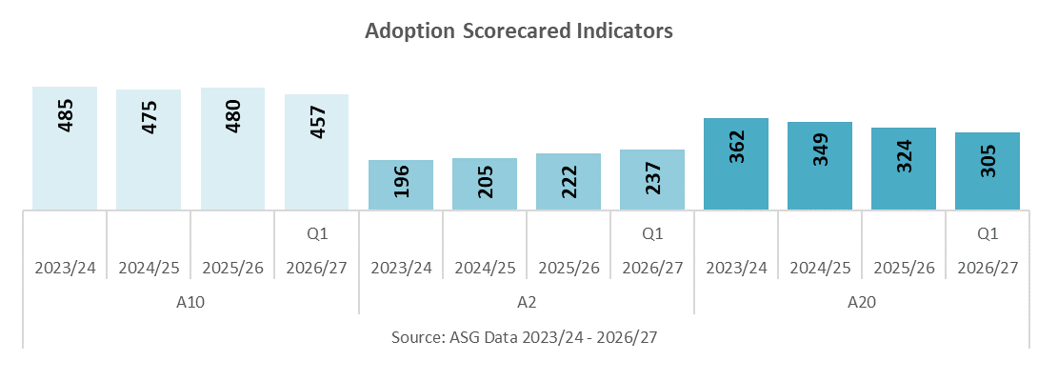
Fig. 8: scorecard indicator average wait times (days) for this quarter and the previous three reporting years

In Q1 2026/27, the overall number of children waiting with a PO decreased. The numbers waiting 18 months or more since entry into care, and, 12 or 18 months or more since the granting of a PO, increased.
Compared with Q4 2025/26 (figs. 9-10), there were:
- 2,970 children with a PO waiting to be placed, a decrease of 1% (n = 40)
- 1,570 children with a PO waiting to be placed 18 months or more since entering care, an increase of 1% (n = 10)
- 950 children with a PO waiting to be placed 12 months or more since its grant, an increase of 1% (n = 10)
- 510 children with a PO waiting to be placed 18 months or more since its grant, an increase of 4% (n = 20)

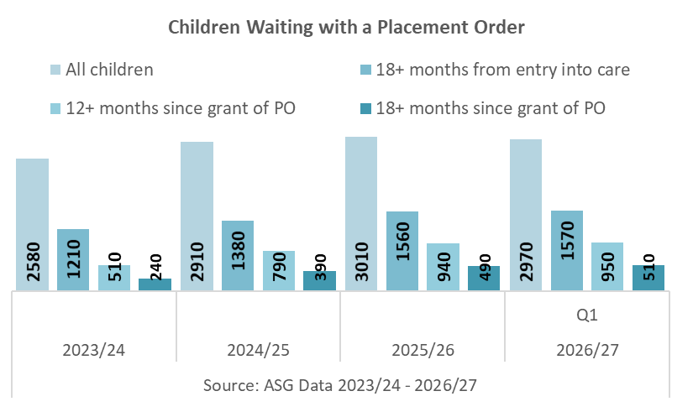
Fig. 9: number of children waiting with a PO but not yet placed, for this quarter and the previous three reporting years

The proportions of children waiting for each of the specified long periods also increased (fig. 10). Compared with Q4 2025/26:
- 53% of children with a PO had been waiting to be placed for 18 months or more since entering care, up from 52%
- 32% had been waiting for 12 months or more since the grant of a PO, up from 31%
- 17% had been waiting for 18 months or more since the grant of a PO, up from 16%

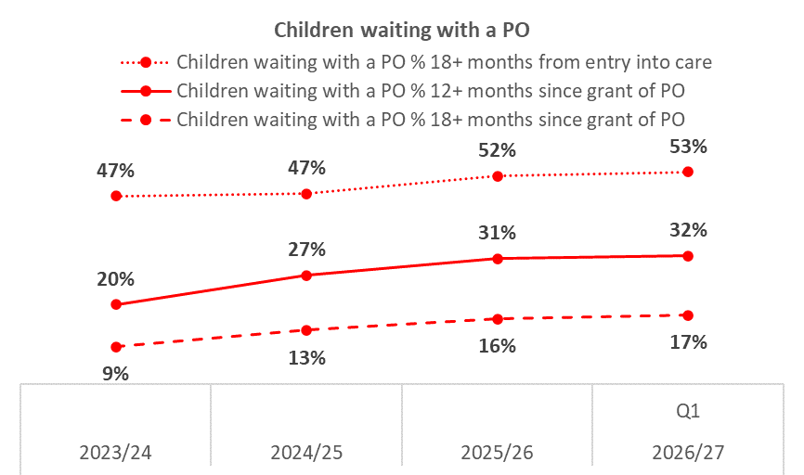
Fig. 10: proportion of children waiting with a PO but not yet placed, for this quarter and the previous three reporting years.

CHARACTERISTICS OF CHILDREN WAITING AND ADOPTED

Children with one or more HTP characteristics are those aged 5 years and over, with a disability, in a sibling group, or from an ethnic-minority group, excluding White-minority groups. These categories overlap, so figures for the individual characteristics should not be added together. Children with HTP characteristics wait longer for adoption on average.

Harder to place (HTP) characteristics
In Q1 2026/27, there were (fig 11):
- 270 children with HTP characteristics adopted, 22% of the 1,230 annual count for 2025/26
- 1,740 children with HTP characteristics waiting with a PO, a decrease of 3% (n = 60)
- 1,110 children with HTP characteristics waiting with a PO for 18 months or more since entering care, an increase of 2% (n = 20)
- 690 children with HTP characteristics waiting for 12 months or more since the grant of a PO, an increase of 2% (n = 10)
- 390 children with HTP characteristics waiting for 18 months or more since the grant of a PO, an increase of 5% (n = 20)

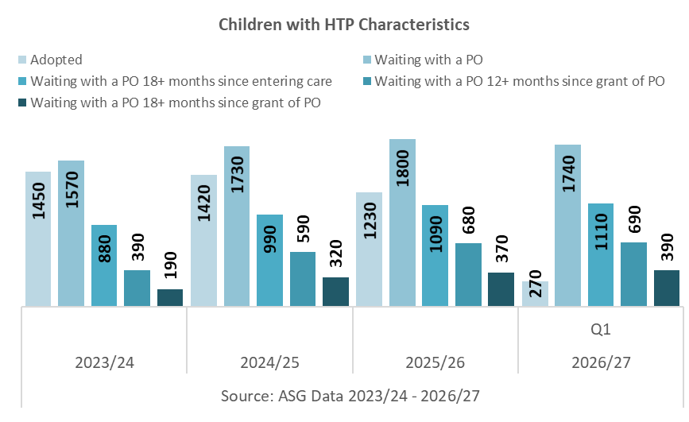
Fig. 11: number of children with one or more HTP characteristics who were adopted or were waiting with a PO, for this quarter and the previous three reporting years

Comparison with 2025/26 (end of reporting year)
In Q1 2026/27 the proportion of adopted children with HTP characteristics decreased, and, the proportion of all children waiting with a PO who had HTP characteristics all decreased. Within the long-wait groups (12 and 18 months plus), the changes in proportions with HTP characteristics broadly decreased (fig. 12). Specifically, compared with Q4 2025/26:
- 44% of all children adopted had HTP characteristics, down from 45% (a decrease of 1 percentage point)
- 59% of all children waiting with a PO had HTP characteristics, down from 60% (a decrease of 1 percentage point)
- 71% of children waiting 18 months or more since entering care had HTP characteristics, up from 70% (an increase of 1 percentage point)
- 73% of children waiting 12 months or more since the grant of a PO had HTP characteristics, up from 72% (an increase of 1 percentage point)
- 76% of children waiting 18 months or more since the grant of a PO had HTP characteristics, the same as last quarter
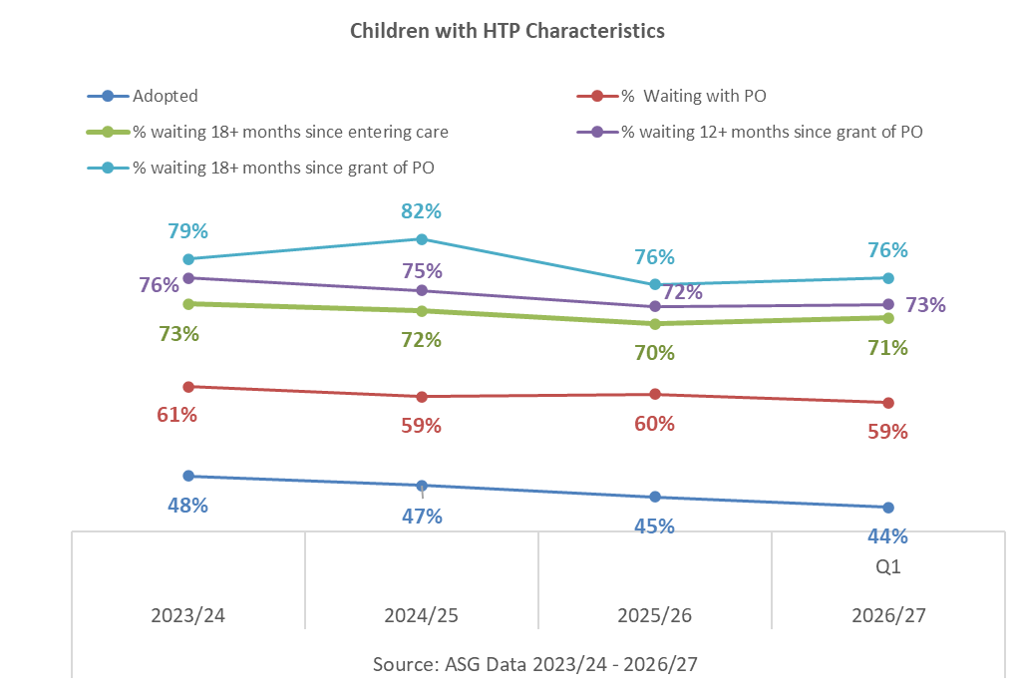
Fig. 12: proportion of children with one or more HTP characteristics who were adopted or were waiting with a PO for this quarter and the previous three reporting years

Figure 13 shows the number and percentage of children waiting and adopted in Q1 2026/27 according to HTP characteristics.

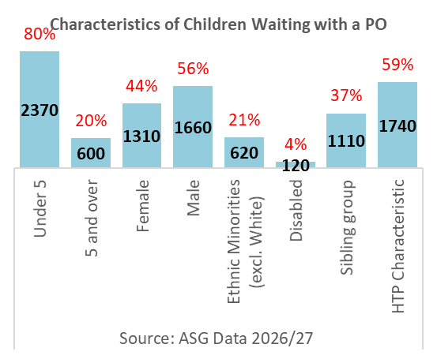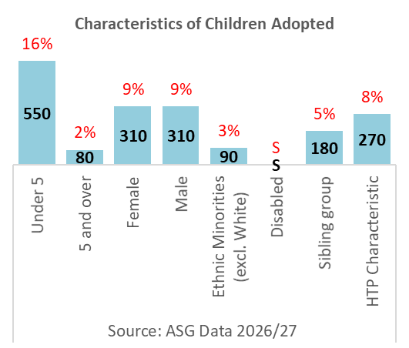
Fig. 13: graphs showing the breakdown of children waiting with a PO (left) and adopted (right) in 2026/27 by HTP characteristics.

CHILDREN’S TIMELINESS BY CHARACTERISTICS
In Q1 2026/27, the average time from entry into care to the report date for all children waiting with a PO was 652 days, 6 days longer than in Q4 2025/26. Children aged 5 years and over waited the longest, at 933 days, followed by children with a disability at 838 days, children classified as ‘harder to place’ (specifically with one or more HTP characteristic) at 738 days, and black and ethnic-minority children at 726 days (fig. 14).
The average time from a PO being granted to the report date was 316 days, 7 days longer than in Q4 2025/26. Children aged 5 years and over waited the longest, at 510 days, followed by children with a disability at 493 days, children classified as harder to place at 372 days, and ethnic-minority children at 349 days (fig. 15).
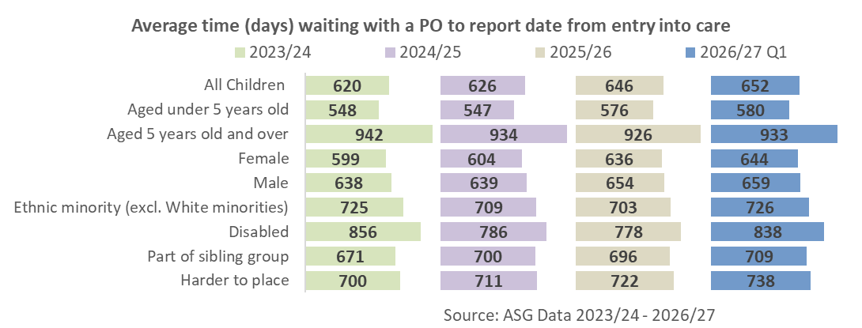
Fig. 14: average time since entry into care for children waiting with a PO for this quarter and the previous three reporting years
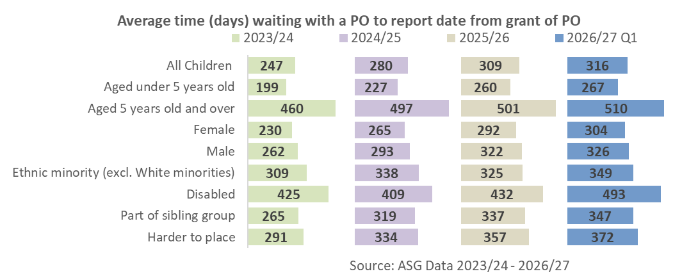
Fig. 15: Average time from the grant of a PO to the report date for this quarter and the previous three reporting years

The average time from entry into care to adoption was 802 days, 14 days shorter than in Q4 2025/26. The longest average journey was for children aged 5 years and over, at 1,332 days, followed by children with a disability, at 1,188 days, and children in a sibling group, at 960 days (fig. 16).

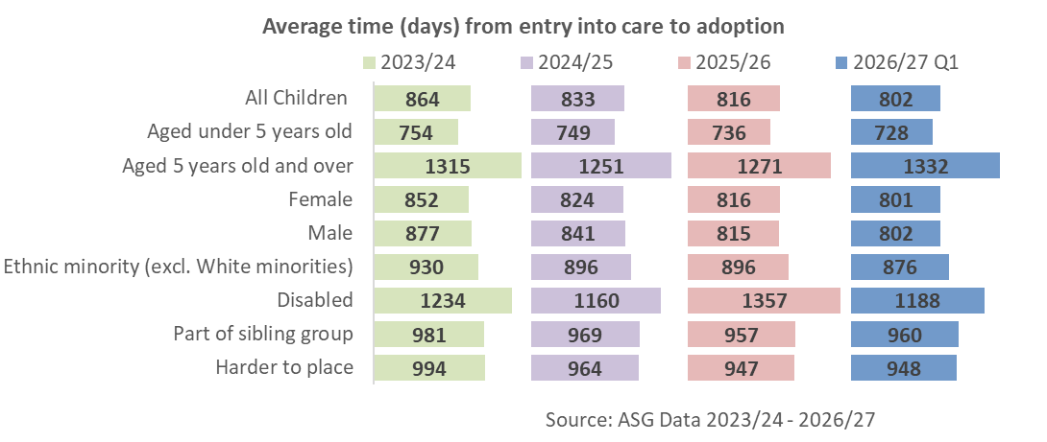

Fig. 16: average waiting time of children from entry into care to adoption for this quarter and the previous three reporting years

SPECIAL GUARDIANSHIP ORDERS (SGOs)
In Q1 2026/27, the number of SGOs remained the same compared to the Q4 2025/26, although the overall profile of children and special guardians remained broadly the same. Children aged 1 to 4 remained the largest child age group, while grandparents continued to account for the majority of special guardians.

CHARACTERISTICS OF CHILDREN
In Q1 2026/27 there were 970 SGOs granted, the same as in Q4 2025/26 (fig. 4). More children are still leaving care via an SGO than an AO, with SGOs accounting for 61% of all permanence.
Compared to last reporting year, the demographic profile of children subject to a SGO remained broadly similar overall (fig. 17). Specifically:
- 53% of the children were male and 47% were female, compared to 49% and 51%, respectively, in Q4 2025/26
- 4% of SGOs were granted to children with a disability, compared to 6% in Q4 2025/26
- 47% of SGOs were granted to children aged under 5, compared to 46% in Q4 2025/26; 55% to children aged 5 years and over, compared to 54% in Q4 2025/26
- 20% of SGOs were granted to children from an ethnic-minority group (excluding White-minority groups), compared to 19% in Q4 2025/26
- 42% of the children were in a sibling group of two or more, compared to 43% in Q4 2025/26

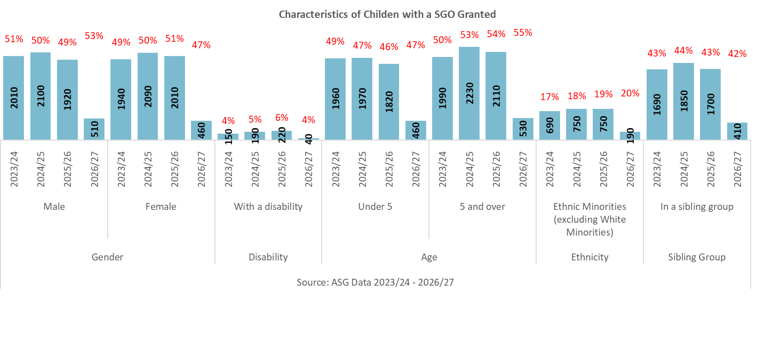

Fig. 17: number and proportion of children granted a SGO for this quarter and the previous three reporting

Children aged 1 to 4 remain proportionately the largest group of children who leave care with an SGO (37%), followed by children aged 5 to 9 (28%) fig. 18).
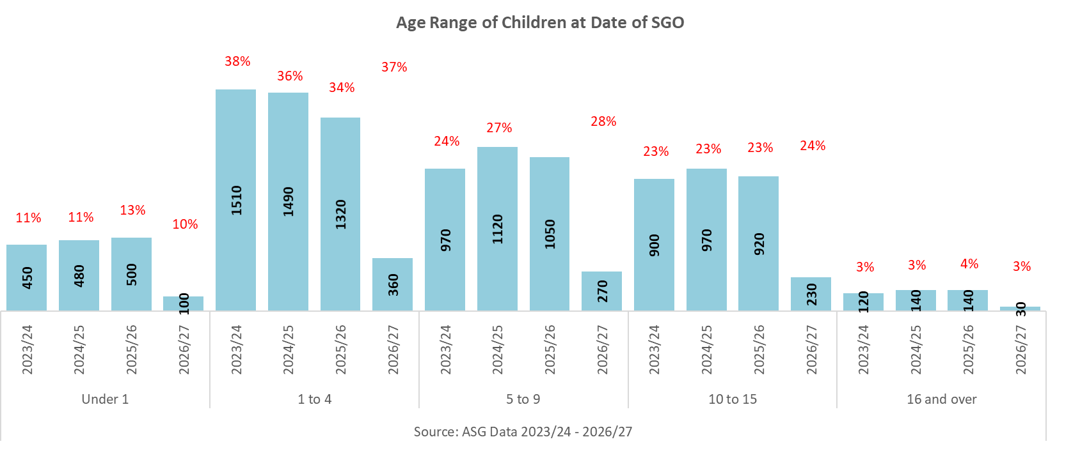
Fig. 18: number and proportion of children granted a SGO by age range, for this quarter and the previous three reporting

The ethnic profile of children granted a SGO remained similar to last reporting year as a whole, with children of White ethnicity remaining the largest group at 80% (fig. 19).

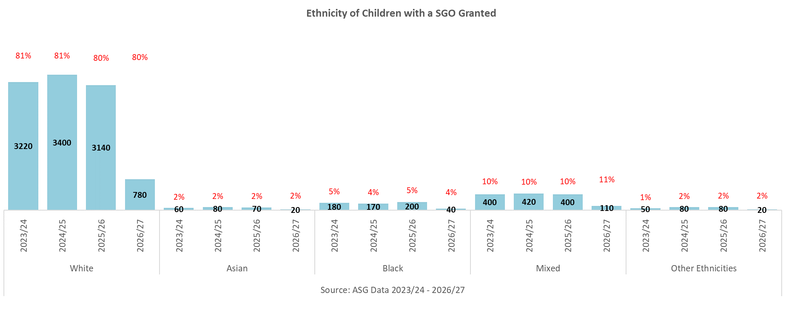
Fig. 19: number and proportion of children granted a SGO by ethnicity, for this quarter and the previous three reporting.

Proportionally, children not in a sibling group continue to be the largest group of children who leave care with an SGO (58%), with the proportion decreasing as group size increases (fig. 20).

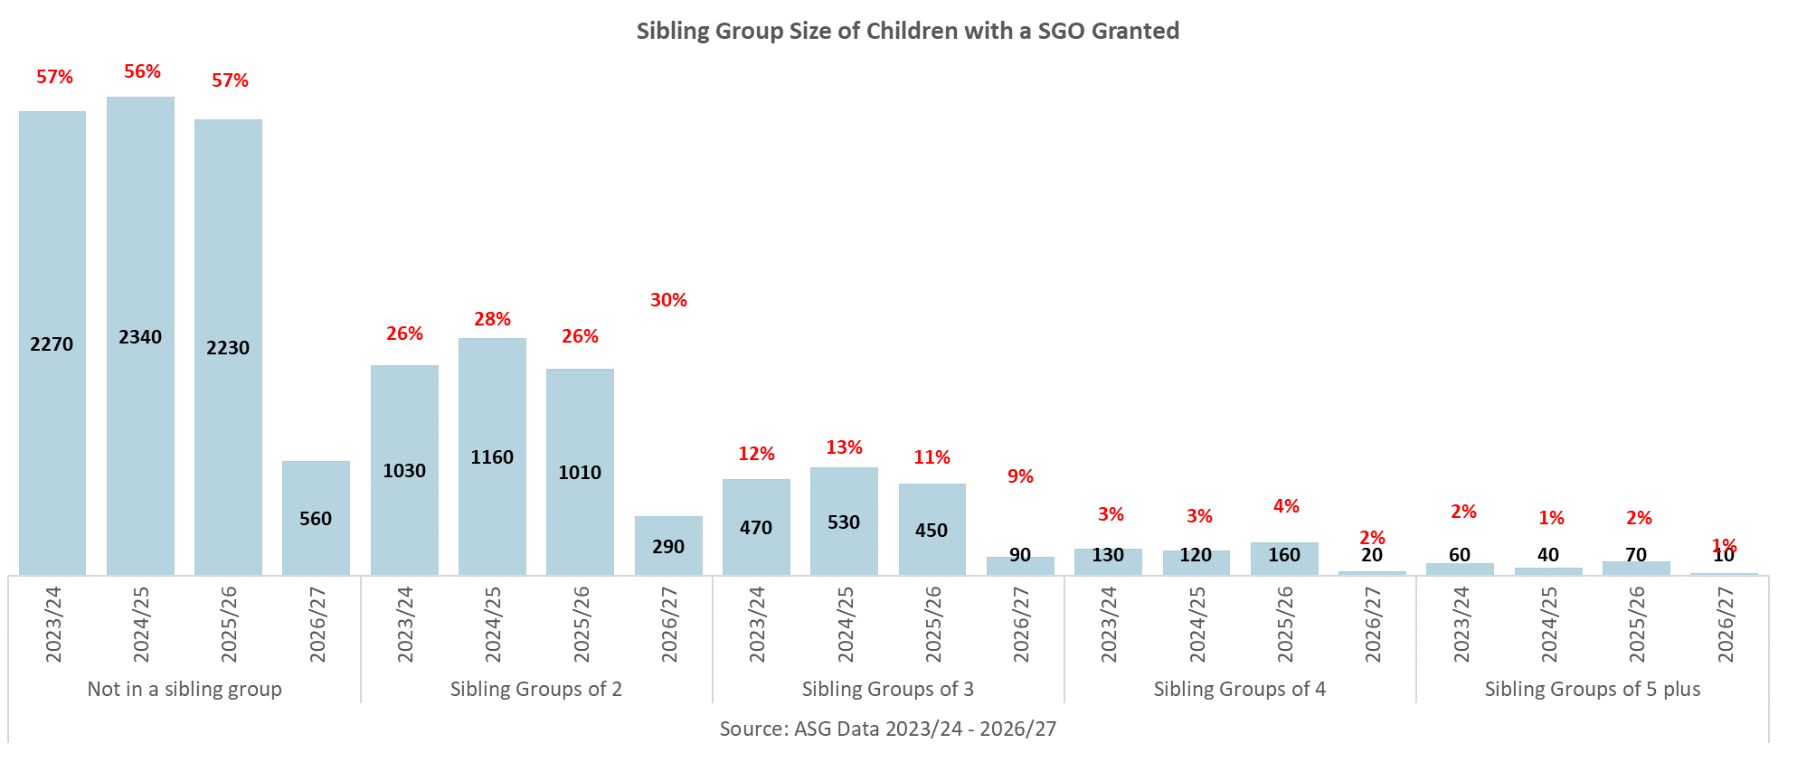
58%
Fig. 20: number and proportion of children granted a SGO by sibling-group size, for this quarter and the previous three reporting.

CHARACTERISTICS OF SPECIAL GUARDIANS

Grandparents are the largest represented group of Special Guardians, with 54% of SGOs granted to grandparents, followed by other family relatives (31%) (fig. 21).

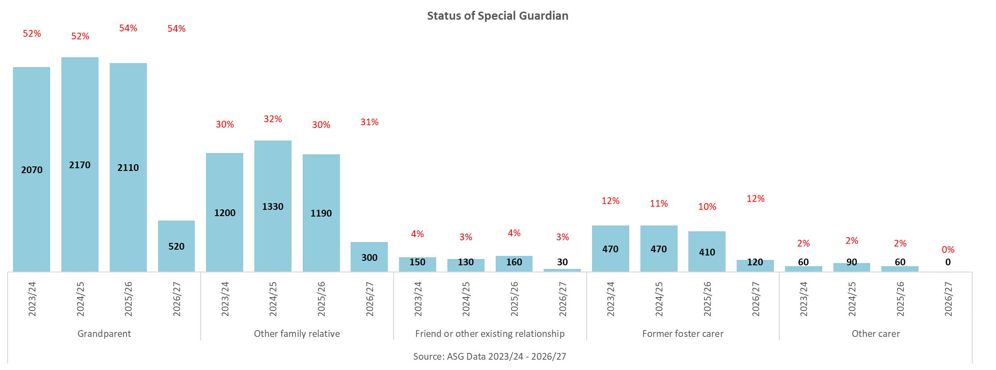

Fig. 21: number and proportion of children by their special guardian’s relationship or status category for this quarter and the previous three reporting.

Figure 22 shows that for Q1 2026/27, Special Guardians aged 50 to 59 are the largest represented age group (28%), followed by and special guardians aged 40 to 49 (25%), proportionally similar to previous years.
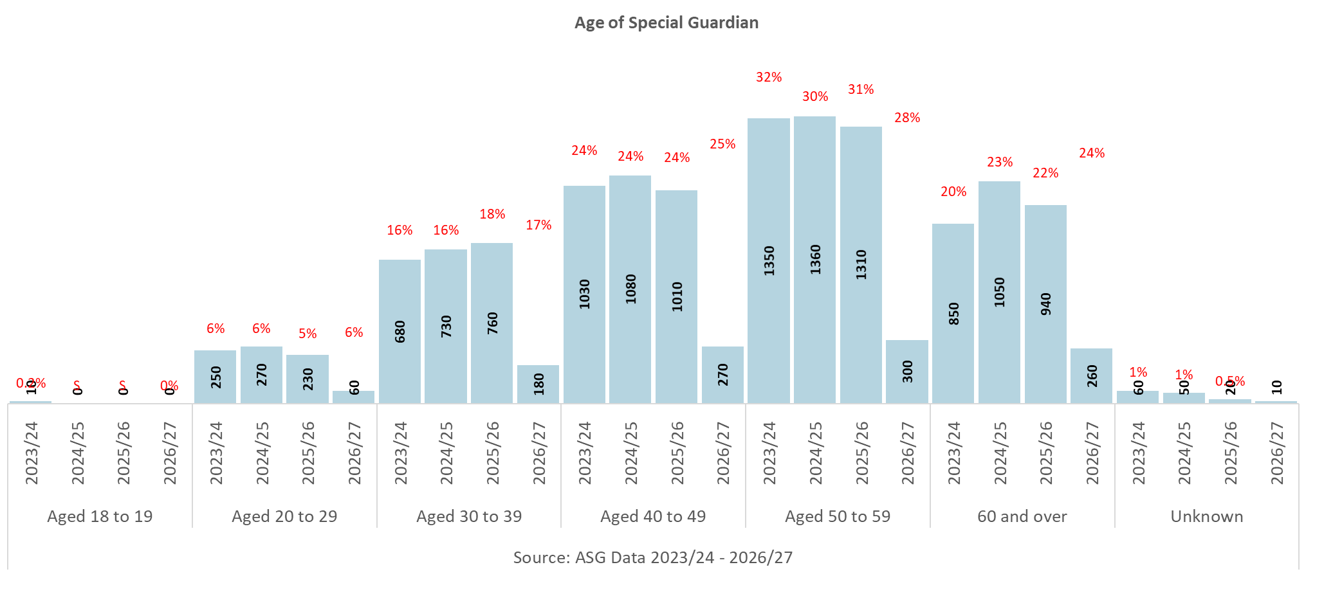
1%
Fig. 22: number and proportion of special guardians by age range for this quarter and the previous three reporting. ‘S’ indicates a count below five that has been suppressed. Where a child has more than one special guardian, both guardians are included

ADOPTERS
Most adopter activity measures decreased in 2025/26 when compared to the previous quarter: registrations, approvals, and adopter families waiting all decreased. Adopter families matched and placed, and prospective families not yet approved all increased.
The proportion of adopters approved within six months of registration fell, while the proportion matched within three months of approval increased.

RECRUITMENT AND PROGRESSION

Change since Q4 2025/26
In Q1 2026/27, both adopter registrations (fig. 23) and approvals (fig. 24) decreased compared to last quarter. Compared with Q4 2025/26, there were:
- 770 registrations, a decrease of 7% (n = 60). This was also a decrease of 5% (n = 40) when compared to Q1 2025/26.
- 470 approvals, a decrease of 16% (n = 90). This was also a decrease of 11% (n = 60) when compared to Q1 2025/26.

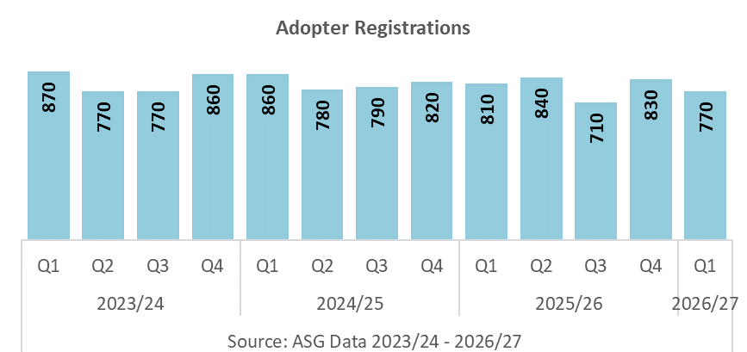
Fig. 23: number of adopter registrations for each quarter since 2023/24.

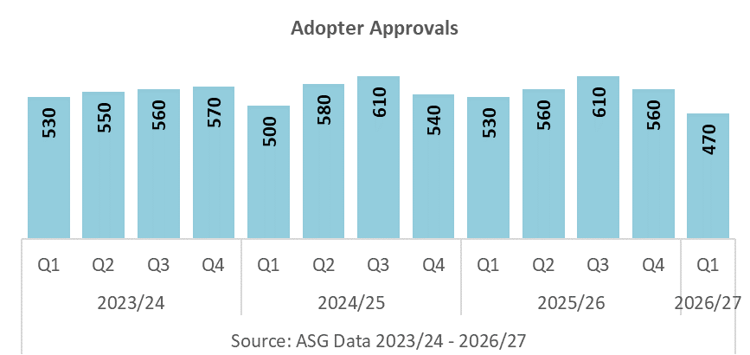
Fig. 24: number of adopter approvals for each quarter since 2023/24.
The number of adopter families matched (fig 25) and placed (fig. 26) increased. Compared with Q4 2025/26, there were:
- 480 adopter families matched with children, an increase of 9% (n = 40). However, this was a decrease of 14% (n = 80) when compared to Q1 2025/26.
- 470 adopter families with a child placed, an increase of 2% (n = 10). However, this was a decrease of 15% (n = 80) when compared to Q1 2025/26.

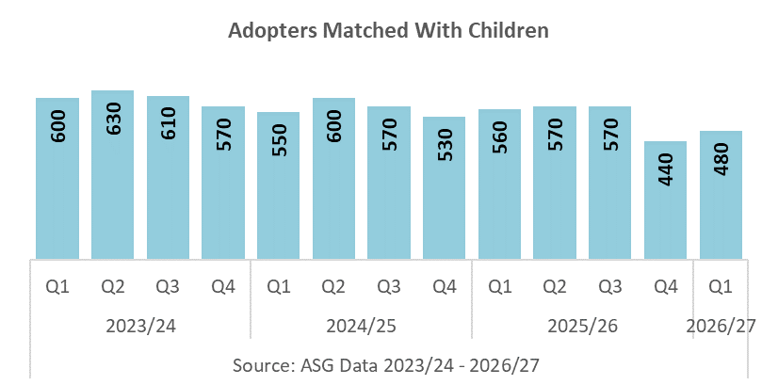
Fig. 25: number of adopter families matched for each quarter since 2023/24.

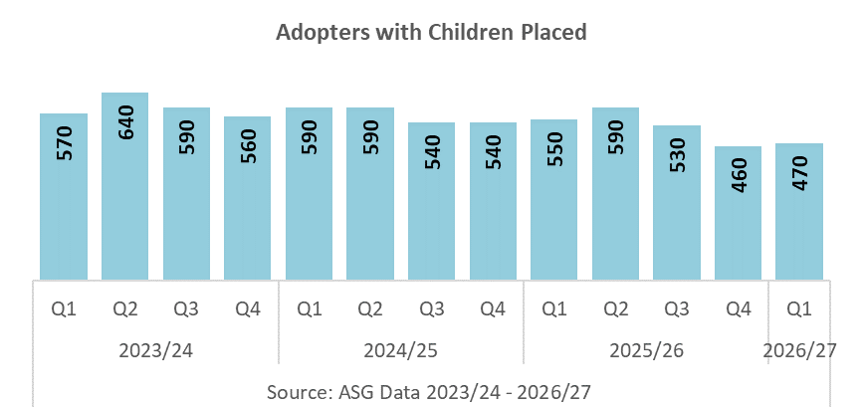
Fig. 26: number of adopter families placed for each quarter since 2023/24.

In Q1 2026/27, the number of prospective adopters not yet approved increased and the number approved and still waiting declined (fig. 27). Compared with Q4 2025/26, there were:
- 2,190 prospective adopter families not yet approved, an increase of 8% (n = 160)
- 1,350 approved adopter families waiting to be matched, a decrease of 4% (n = 50)

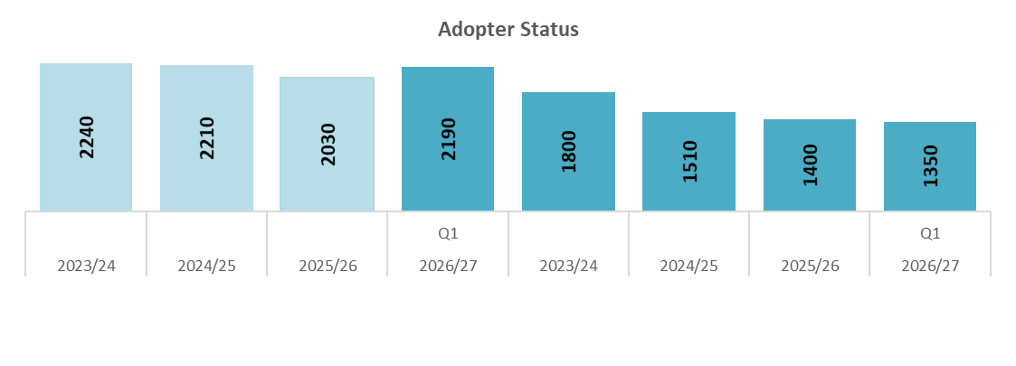
Fig. 27: number of adopter families not yet approved or approved but not yet matched, for this quarter and the previous three reporting.

ADOPTER TIMELINESS

Change since 2025/26
In Q1 2026/27 there was an increase in the proportion matched within three months of approval (fig. 28). Compared with last reporting year 2025/26:
- 19% of adopter families were approved within six months of registration, a decrease of 5 percentage points
- 27% of adopter families matched during the quarter were matched within three months of approval, an increase of 2 percentage points

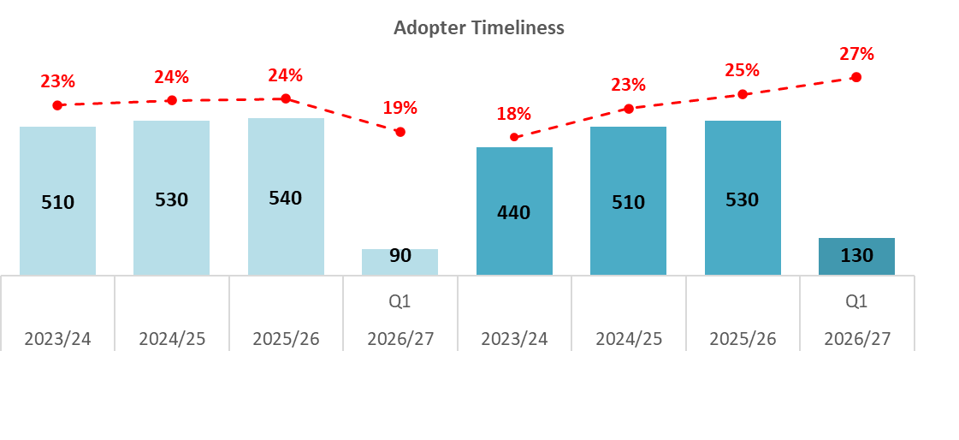
Fig. 28: adopter timeliness by number and proportion for this quarter and the previous three reporting.

PLACEMENT PROVIDERS

Change since 2025/26
Figure 29 shows the proportional split by placement provider. Compared with last reporting year 2025/26, in Q1 2026/27 the proportion of children placed with:
- ‘Own RAA’ decreased by 3 percentage points to 76%
- ‘Other RAA’ decreased by 1 percentage points to 5%
- ‘VAA’ increased by 3 percentage points to 16%
- Local Authorities or VAAs outside England were unchanged at 2%

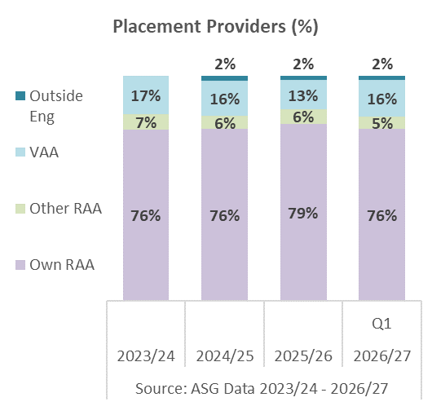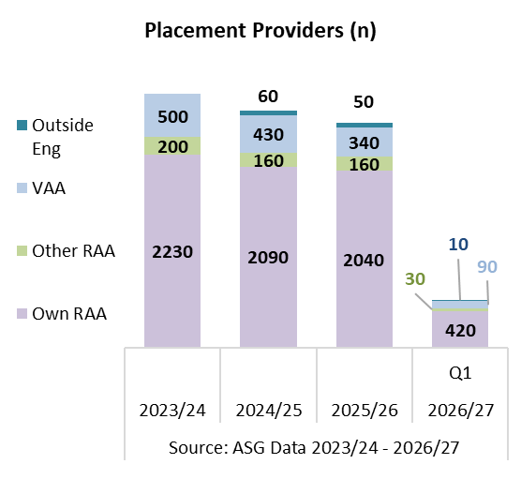
Fig. 29: proportion (left) and number (right) of children placed for adoption, by placement provider, for this quarter and the previous three reporting.

FAMILY FINDING AND WITHDRAWALS

Change since Q4 2025/26
There was little change in the family finding status overall. Compared with Q4 2025/26, the proportion of adopter families (fig. 30):
- That were in active family finding saw a slight increase of 1 percentage point to 47% (n = 640)
- That were expected to go on hold or withdraw remained the same at 8% (n = 110)
That had a child found but were not formally matched at panel decreased by 1 percentage points to 36% (n = 490)
There were 40 adopter families that withdrew after approval, 10 fewer than last quarter, representing a 20% decrease (n = 10) (fig. 31).

Fig. 30: proportion and number of adopter families by family finding status, compared with Q4 2025/26.

Fig. 31: number of adopters that withdrew from the process after approval for each quarter since 2023/24.

SUFFICIENCY OF ADOPTERS
At the end of this reporting quarter, the number of children waiting with a PO (n = 2,970) exceeded the number of approved adopter families waiting (n = 1,350) by 1,620 (fig. 32). Because one adopter family may be able to care for either one child or a sibling group, this difference is not an estimate of the number of additional families required. It is a broad indicator of the imbalance between children and available approved families.

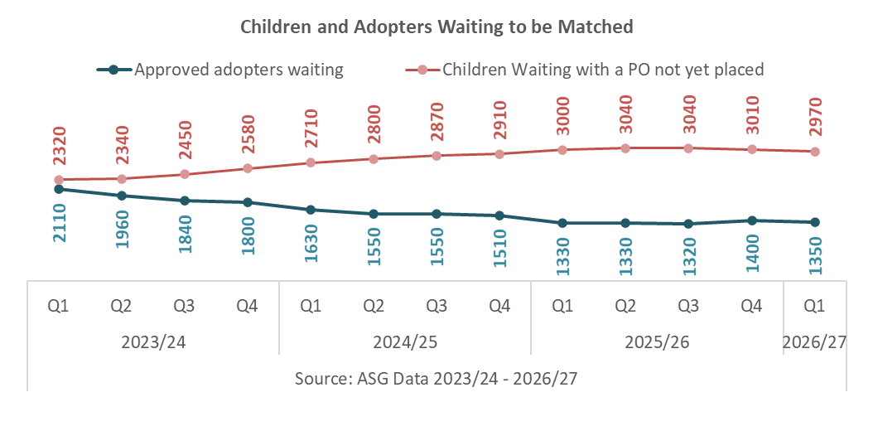
Fig. 32: comparison of children waiting with a PO not yet placed, and approved adopters waiting to be matched, for each quarter since 2023/24.

Figure 33 provides the more comparable family-level measure of adopter sufficiency. It shows that there were:
- 2,010 children with active family finding
- 640 adopter families with active family finding
- 1,580 adopter families estimated to be needed, based on the number of single children and sibling groups waiting to be placed
- 940 estimated shortfall of adopter families, which takes into account those children intended to be placed in a family as part of their sibling group

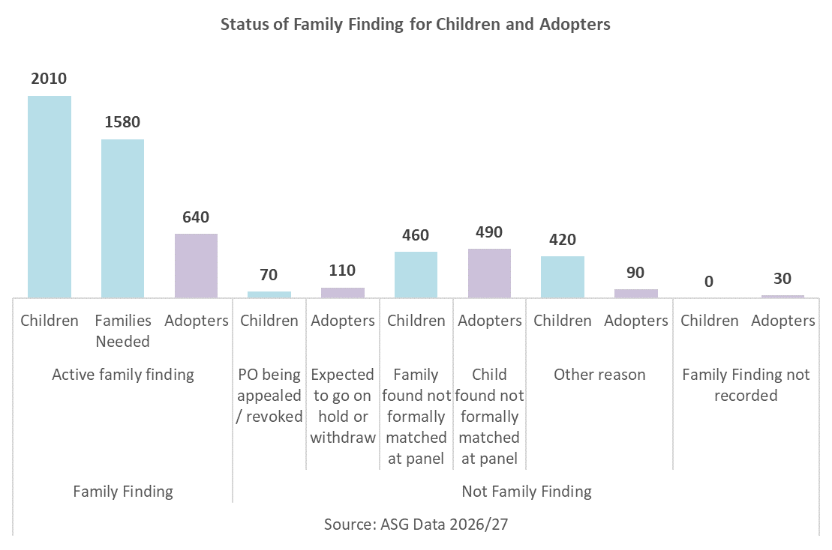
Fig. 33: Family finding status for children and adopters at 30th June 2026.

ADOPTER PIPELINE
Figure 34 shows quarterly figures of registrations and approvals since 2023/24, and quarter-end counts of prospective adopters, not yet approved, and approved adopters who are waiting.
Compared with Q4 2025/26, the total number of adopter registrations and approvals were lower in Q1 2026/27. The numbers of prospective adopters not yet approved increased, and the number of approved adopters who are waiting decreased.
In Q1 2026/27, compared to Q4 2025/26, there were:
- 770 registrations, a decrease of 7% (n = 60)
- 470 approvals, a decrease of 16% (n = 90)
- 2,190 prospective adopter families not yet approved, an increase of 8% (n = 160)
- 1,350 approved adopter families waiting, a decrease of 4% (n = 50)

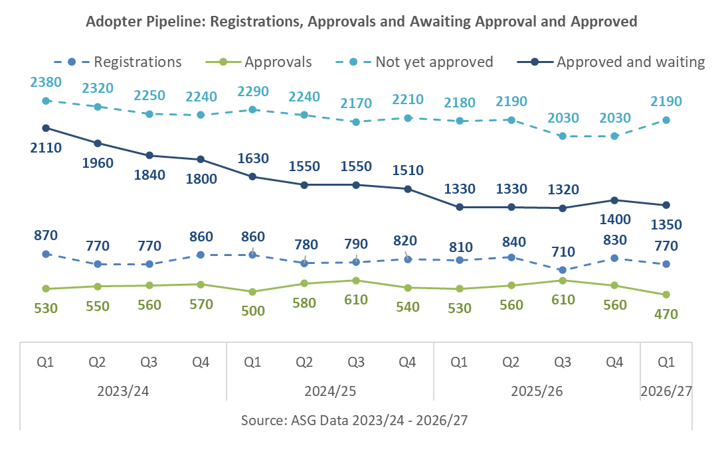
Fig. 34: adopter pipeline for each quarter since 2023/24.

PIPELINE BALANCE

Longer-term trend
Prior and since Q1 2023/24, the number of children granted POs was higher than the number of adopter families approved. These measures are not directly comparable because they count children and families respectively, and one family may adopt more than one child. Nevertheless, the consistent difference indicates continuing pressure on the supply of approved adopters. In Q12026/27, the difference between the quarterly figures increased from 100 in Q4 2025/26 to 150 (Figure 35).

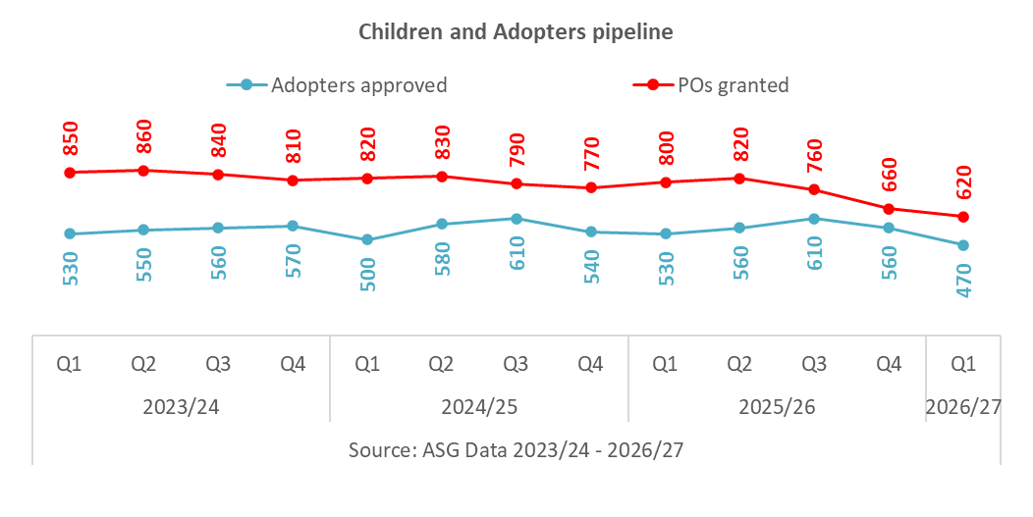
Fig. 35: children and adopter pipeline comparison per quarter for each quarter since 2023/24.

CONCLUDING REMARKS
The Q1 2026/27 data indicate continuing pressure on adopter sufficiency and persistent long waits for children. At 30th June 2026, 2,970 children with a Placement Order were waiting to be placed, a decrease of approximately 1% from the previous quarter. However, the number waiting for at least 18 months since entering care increased to 1,570, and the average time since entry into care for children still waiting rose by six days to 652 days. Children with harder to place characteristics remained disproportionately represented among those waiting: they accounted for 59% (slight decrease from 60%) of the waiting population, compared with 44% of children adopted during the quarter.
Adopter recruitment and progression presented a mixed picture. Registrations fell by 7% and approvals by 16% compared with Q4 2025/26, while the number of approved families waiting to be matched fell to 1,350. Conversely, prospective families awaiting approval increased by 8% to 2,190, and the numbers of adopter families matched and with children placed both increased. The family-level sufficiency analysis estimated that 1,580 families were needed for children in active family finding, compared with 640 approved families actively seeking a match, giving an estimated shortfall of 940 families.
There were improvements in some outcomes. The number of children matched increased by 10% from the previous quarter. The average completed journey from entry into care to adoption was 802 days, compared with 816 days in 2025/26, while the proportion of adopter families matched within three months of approval increased from 25% to 27% over the same comparison periods. SGOs remained at 970, unchanged from Q4.

DATA SOURCES

ASG QUARTERLY DATA COLLECTION
In Q1 2026/27, response rates for the local-authority child-level and adopter-level sections were both 100%. The response rate for the voluntary-adoption-agency adopter-level section was also 100%. National and regional figures on adoptions and adopters therefore do not include estimates for non-response.

DfE SSDA 903 DATA COLLECTION
Local authorities provide data on their looked after children using the SSDA903 collection. Data are collected from all local authorities. The information is collected at child level and includes information about the child’s characteristics and their dates for each stage of the care process, including adoption. The data undergo thorough quality assurance and local authorities are able to update their historical data annually. We therefore view this as the most robust source of information on adoption. It is used to produce the Children looked after in England including adoption (SFR) and the Adoption Scorecards.

DATA SOURCE NOTES:
Figures 14-16 are calculated from individual child records containing valid dates and relevant characteristics. Unrounded child-level values were used to produce the most accurate average waiting times by child characteristic shown in figures 14-16. Only national aggregate averages are presented; no individual-level values or potentially identifiable small counts are reported.

ABOUT THIS PUBLICATION
This publication was produced by The Adoption and Special Guardianship (ASG) Data Management Service, Coram, on behalf of the Department for Education.

download: ASG Quarterly Data
email: asglb@coram.org.uk
write: Coram, Coram Campus, 41 Brunswick Square, London WC1N 1AZ

children aged 5 years and over, with a disability, in a sibling group, or from an ethnic-minority group excluding White-minority groups.
How long children and adopter families take to reach key stages in the adoption process, measured either in days between specified milestones or as the proportion progressing within a stated period.
Average time from court authority to place a child to the local authority’s decision on an adoptive match.
Average time from entry into care to the local authority receiving court authority to place the child.
This comparison does not account for sibling groups, appropriateness of matches or placements and should be treated as a broad indicator of imbalance rather than a literal estimate of the number of additional families required. However, it does indicate a lack of adopter families and the related pressure on the system that has grown substantially over the last three years.
The process of identifying and securing a suitable permanent family for a child.
This comparison uses the previous annual distribution of reversal reasons as a baseline for assessing the current quarter.
The ‘harder to place’ category in figures 14-16 relates to children with one or more HTP characteristic; values within this category should therefore not be simply added together with any other HTP value in that same figure when conducting any calculation.
The number of children placed is calculated from data collected from Local Authorities as part of the ASG data collection. VAAs record their own placement data – as such there can be discrepancies between the data reported here and the totals calculated from VAA records. This should be taken into account when interpretating the data presented here.

